PROJECT REPORT
STUDENT ENROLLMENT & COURSE MANAGEMENT SYSTEM (SECMS)
A Salesforce-Based Academic Enrollment Management Application
Submitted as a Group Project under the
TN Skills – Naan Mudalvan Programme

S. No. | Student Name | Registration Number
1 | Ruqaiya Sadeem K F | _________31224U09073_________
2 | Shaina Sadaf N Khan | _________31224U09081_________
3 | Moolakadai Musfera Konain | _________31224U09058_________
4 | Vinothini S | _________31224U09093_________
5 | Nivetha M | _________31224U09069_________

Group ID: SWTID-2026-4095
BACHELOR OF COMPUTER APPLICATIONS (BCA)
5th Semester
Islamiah Women's Arts and Science College
Affiliated to Thiruvalluvar University
Academic Year 2026–2027

CERTIFICATE
This is to certify that the group project entitled “Student Enrollment & Course Management System (SECMS)” has been prepared and documented by the following students of the Bachelor of Computer Applications (BCA), 5th Semester, Islamiah Women's Arts and Science College, affiliated to Thiruvalluvar University, under the TN Skills – Naan Mudalvan Programme during the academic year 2026–2027.
S. No. | Name | Email ID
1 | Ruqaiya Sadeem K F | rsadeem2005@gmail.com_________
2 | Shaina Sadaf N Khan | shainasadafn2007@gamil.com
3 | Moolakadai Musfera Konain | musfirakounain.06@gmail.com
4 | Vinothini S | vinothinisiva164@gmail.com
5 | Nivetha M | karannive2603@gmail.com

Group ID: SWTID-2026-4095
The project documents the analysis, design, configuration, automation, reporting, security setup, and testing of a Salesforce-based Student Enrollment & Course Management System.

ACKNOWLEDGEMENT
We express our sincere gratitude to Islamiah Women's Arts and Science College and Thiruvalluvar University for providing the academic environment and opportunity to undertake this group project under the TN Skills – Naan Mudalvan Programme.
We are thankful for the learning resources and practical exposure that supported our understanding of Salesforce, cloud-based application configuration, data modelling, automation, reporting, dashboards, and security. The project enabled us to apply software-development concepts to an academic enrollment-management scenario.
We also acknowledge the contribution of all five group members in planning, configuring, testing, documenting, and reviewing the Student Enrollment & Course Management System.

ABSTRACT
The Student Enrollment & Course Management System (SECMS) is a Salesforce-based application designed to centralize and streamline academic enrollment operations. The system brings student, course, instructor, and enrollment information into a unified cloud environment and supports structured workflows for enrollment processing, validation, approval, instructor assignment, reporting, and monitoring.
The project addresses problems associated with fragmented and manual enrollment processes, including scattered data, delayed reporting, duplicate entries, approval bottlenecks, and limited visibility into academic operations. Salesforce Lightning provides the user interface and Salesforce Objects provide the data layer, while Flows, Validation Rules, Approval Processes, Reports, Dashboards, Profiles, Permission Sets, and sharing settings support automation, monitoring, and access control.
The report documents the project from ideation and requirement analysis through system design, Agile-style planning, development, functional and performance testing, limitations, conclusion, and future scope. Screenshot markers are provided throughout the development and testing chapters so that the group's actual Salesforce implementation screenshots can be inserted before final submission.

LIST OF FIGURES
- Figure 1.1 Project overview and system purpose
- Figure 2.1 Problem statement model
- Figure 2.2 Empathy map – Enrollment Officer
- Figure 3.1 Customer journey map
- Figure 3.2 Data flow diagram
- Figure 4.1 Proposed solution architecture
- Figure 6.1 Salesforce Developer Account
- Figure 6.2 Student Custom Object
- Figure 6.3 Course Custom Object
- Figure 6.4 Enrollment Custom Object
- Figure 6.5 Instructor Custom Object
- Figure 6.6 Student Fields
- Figure 6.7 Course Fields
- Figure 6.8 Instructor Fields
- Figure 6.9 Enrollment Fields
- Figure 6.10 Enrollment–Student Relationship
- Figure 6.11 Enrollment–Course Relationship
- Figure 6.12 Enrollment–Instructor Relationship
- Figure 6.13 Student Tab
- Figure 6.14 Course/Instructor/Enrollment Tabs
- Figure 6.15 Lightning App Configuration
- Figure 6.16 Lightning App Navigation
- Figure 6.17 New Enrollment Record Type
- Figure 6.18 Re-Enrollment Record Type
- Figure 6.19 New Enrollment Page Layout
- Figure 6.20 Re-Enrollment Page Layout
- Figure 6.21 Student Related List
- Figure 6.22 Course Related List
- Figure 6.23 Instructor Related List
- Figure 6.24 Student Email Validation Rule
- Figure 6.25 Fees-Paid Validation Rule
- Figure 6.26 Enrollment Approval Process
- Figure 6.27 Final Approval Configuration
- Figure 6.28 Final Rejection Configuration
- Figure 6.29 Enrollment Date Flow
- Figure 6.30 Enrollment Approval Notification Flow
- Figure 6.31 Instructor Assignment Flow
- Figure 6.32 Follow-Up Task Flow
- Figure 6.33 Students by Status Report
- Figure 6.34 Enrollments by Course Report
- Figure 6.35 Pending Enrollment Approvals Report
- Figure 6.36 Revenue Report
- Figure 6.37 Student Management Dashboard
- Figure 6.38 Profile Configuration
- Figure 6.39 Permission Sets
- Figure 6.40 Sharing Settings / OWD

LIST OF TABLES
- Table 1.1 Project identification
- Table 3.1 Functional requirements
- Table 3.2 Non-functional requirements
- Table 3.3 Technology stack
- Table 5.1 Product backlog
- Table 5.2 Sprint schedule
- Table 6.1 Student object fields
- Table 6.2 Course object fields
- Table 6.3 Instructor object fields
- Table 6.4 Enrollment object fields
- Table 7.1 Functional test cases
- Table 7.2 Validation and automation tests
- Table 7.3 Reporting and dashboard tests
- Table 7.4 Security verification tests
- Table 8.1 Advantages and limitations
- Table A.1 Team member contribution

1. INTRODUCTION

1.1 Project Identification
Item | Details
Project Title | Student Enrollment & Course Management System (SECMS)
Group ID | SWTID-2026-4095
Programme | TN Skills – Naan Mudalvan Programme
Course | Bachelor of Computer Applications (BCA)
Semester | 5th Semester
College | Islamiah Women's Arts and Science College
University | Thiruvalluvar University
Academic Year | 2026–2027
Technology Platform | Salesforce
Project Type | Group Project
Team Size | Five members

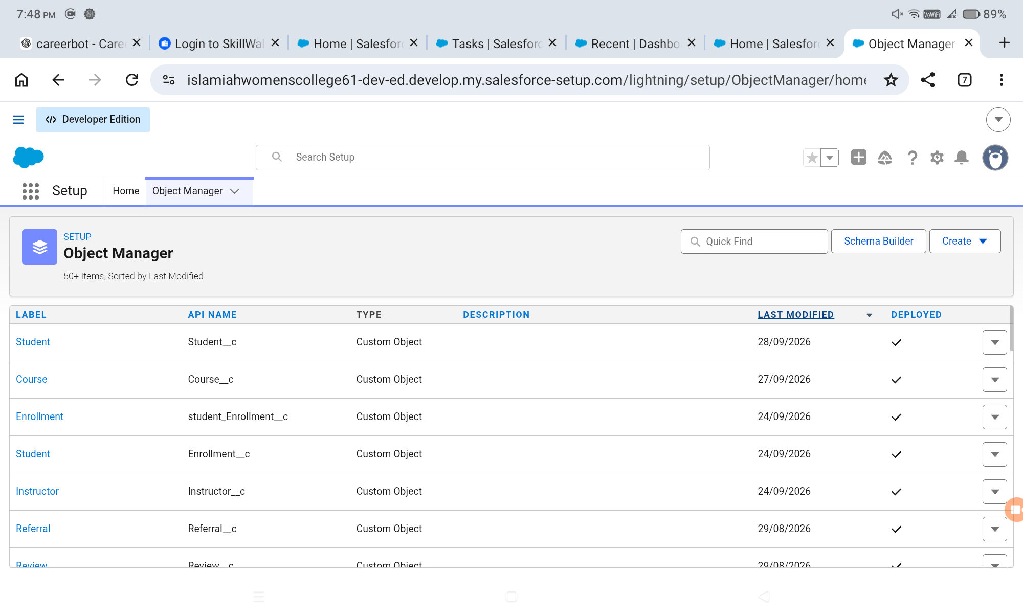

1.2 Project Overview
The Student Enrollment & Course Management System is a comprehensive Salesforce application intended to streamline and automate academic enrollment operations. It centralizes student, course, instructor, and enrollment data and provides structured processes for enrollment requests, validation, approval, instructor assignment, reporting, and monitoring.
The project uses Salesforce Lightning as the user interface, Salesforce custom objects as the database layer, Salesforce Flows for automation, Validation Rules for data integrity, Approval Processes for controlled enrollment decisions, Reports and Dashboards for monitoring, and security configuration for controlled access.
Figure 1.1: Project overview and Salesforce application interface
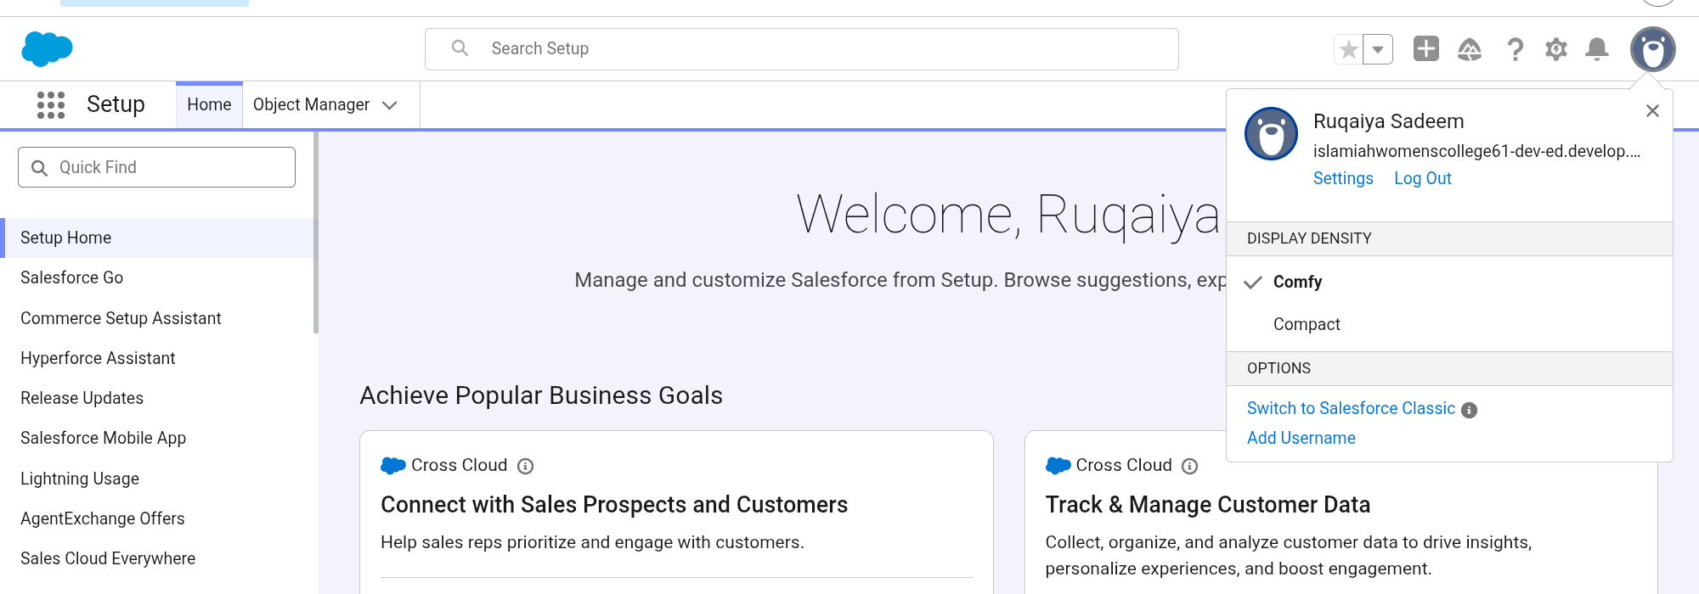

1.3 Purpose of the Project
The primary purpose of SECMS is to replace manual and fragmented enrollment processes with a structured, scalable, automated, and secure Salesforce solution. The system is intended to support accurate student-data management, organized enrollment workflows, automated validations and approvals, and transparent reporting.
- Accurate management of student information.
- Centralized management of course information.
- Structured processing of enrollment requests.
- Automated validation and approval activities.
- Automatic instructor assignment based on course category.
- Generation of reports and dashboards for operational monitoring.
- Role-based access to relevant records and functions.

1.4 Scope
The scope of the project covers the configuration of a Salesforce application for student enrollment and course management. It includes data objects, fields, relationships, Lightning navigation, record types, page layouts, validation rules, approval processing, flows, reports, dashboards, and security controls. The future-scope items are documented separately and are not treated as current implementation features.

2. IDEATION PHASE

2.1 Problem Statement
The project identifies difficulties experienced by academic enrollment stakeholders when enrollment information is scattered across manual or unintegrated systems. Enrollment officers need to manage student enrollments efficiently, while administrators require timely visibility into enrollment and revenue information.
Stakeholder | Need | Observed Problem | Impact
Enrollment Officer | Manage enrollments efficiently | Enrollment data is scattered | Manual effort and errors
Administrator | Track enrollments and revenue | Reporting is delayed | Reduced visibility for decisions

2.2 Empathy Map – Enrollment Officer
Area | Project Understanding
Think & Feel | Concerned about duplicate bookings, errors, and revenue loss.
Hear | Complaints and follow-up requests from students and management.
See | Multiple spreadsheets, emails, and disconnected information.
Say & Do | Rechecks information and follows up manually.
Pain | Duplicate entries and approval bottlenecks.
Gain | Automation, dashboards, faster processing, and centralized information.

2.3 Brainstorming and Idea Prioritization
- Spreadsheet automation.
- Standalone enrollment portal.
- ERP integration.
- Salesforce-based enrollment system.
The ideas were grouped into manual, semi-automated, and fully automated cloud solutions. The source project identifies the Salesforce-based SECMS approach as the selected solution because it provides a cloud platform for centralized data, automation, reporting, and access control.

3. REQUIREMENT ANALYSIS PHASE

3.1 Customer Journey
The project journey covers the following stages:
- Awareness and registration.
- Course selection.
- Enrollment request.
- Fee payment.
- Approval.
- Instructor assignment.
- Reporting and completion.

3.2 Functional Requirements
FR No. | Epic | Description
FR-1 | Student Management | Manage student records.
FR-2 | Course Management | Create and manage courses.
FR-3 | Enrollment Processing | Request, approve, and reject enrollments.
FR-4 | Instructor Assignment | Automatically assign instructors.
FR-5 | Reporting | Provide dashboards and reports.

3.3 Non-Functional Requirements
ID | Requirement | Description
NFR-1 | Usability | Provide a simple and user-friendly interface with organized tabs, forms, and dashboards.
NFR-2 | Security | Protect sensitive student and institutional data through authorization and access controls.
NFR-3 | Reliability | Process enrollment, approval, and reporting operations consistently and accurately.
NFR-4 | Performance | Provide responsive operations, including quick search and dashboard refresh.
NFR-5 | Scalability | Support growth in students, courses, departments, and users.
NFR-6 | Availability | Support reliable access during institutional working hours and minimize downtime.

3.4 Data Flow Description
The system accepts student and enrollment information from users, validates the information, stores it in Salesforce objects, routes relevant enrollment requests through approval processing, assigns instructors using automation, and makes processed information available through reports and dashboards.
- User inputs student, course, instructor, and enrollment data.
- Validation rules check defined data conditions.
- Enrollment requests are routed through the approval process.
- Flows perform automated updates, notifications, assignments, and follow-up actions.
- Reports and dashboards consume stored data for monitoring.

3.5 Technology Stack
Layer | Technology / Salesforce Component
User Interface | Salesforce Lightning
Logic / Automation | Salesforce Flows
Database | Salesforce Objects
Data Validation | Validation Rules
Approval Automation | Approval Process
Reporting | Salesforce Reports
Visualization | Salesforce Dashboards
Security | Profiles, Permission Sets, Sharing / OWD

4. PROJECT DESIGN PHASE

4.1 Problem–Solution Fit
SECMS aligns the identified enrollment-management problems with Salesforce-native capabilities. Fragmented records are addressed through centralized objects; manual process steps are addressed through flows and approvals; data-quality requirements are supported by validation rules; and monitoring needs are supported through reports and dashboards.

4.2 Proposed Solution
Parameter | Description
Problem | Manual and fragmented enrollment handling.
Solution | Salesforce-based Student Enrollment & Course Management System.
Novelty | End-to-end use of cloud configuration and automation for the enrollment workflow.
Social Impact | Improved visibility and a more structured student-enrollment experience.
Revenue Model | Institutional deployment.
Scalability | Support for multiple departments and future modules.

4.3 Solution Architecture
The solution architecture integrates the Salesforce user interface with custom objects, automation flows, approval processing, reporting, dashboards, and security layers. The Student, Course, Instructor, and Enrollment objects form the core data model. Enrollment records reference the related Student, Course, and Instructor records through lookup relationships.

5. PROJECT PLANNING & SCHEDULING

5.1 Planning Approach
The source project uses an Agile-style planning approach based on epics, user stories, story points, sprints, and velocity-oriented estimation. The project is divided into functional increments covering setup, data modelling, automation, security, reporting, and dashboards.

5.2 Team Composition
Member | Primary Project Contribution
Ruqaiya Sadeem K F | Developer account setup, Flow automation, Reports, Conclusion / documentation.
Shaina Sadaf N Khan | Custom objects, fields, and relationships.
Moolakadai Musfera Konain | Tabs, Lightning App, Page Layouts and Record Types.
Vinothini S | Validation Rules and Approval Process.
Nivetha M | Dashboards and Security Setup.

Note: The contribution allocation above follows the task distribution shown in the group-project reference material supplied for this report.

5.3 Product Backlog
Story | User Story / Task | Points | Priority | Assigned Member
USN-1 | Create Salesforce developer account for project configuration. | 1 | High | Ruqaiya
USN-2 | Create Student, Course, Enrollment, and Instructor objects. | 3 | High | Shaina
USN-3 | Create dedicated tabs for project objects. | 3 | High | Moolakadai
USN-4 | Create relevant fields for academic records. | 5 | High | Shaina
USN-5 | Create centralized Lightning App. | 3 | High | Moolakadai
USN-6 | Define relationships among students, courses, and enrollments. | 5 | Medium | Shaina
USN-7 | Customize page layouts and record types. | 5 | High | Moolakadai
USN-8 | Create validation rules. | 3 | High | Vinothini
USN-9 | Build automated flows. | 3 | High | Ruqaiya
USN-10 | Configure enrollment approval process. | 5 | High | Vinothini
USN-11 | Configure role-based security. | 5 | High | Nivetha
USN-12 | Create operational reports. | 4 | High | Ruqaiya
USN-13 | Create management dashboard. | 4 | Medium | Nivetha

5.4 Sprint Schedule
Sprint | Focus | Planned Duration | Major Deliverables
Sprint 1 | Developer setup | 6 Days | Salesforce Developer Org
Sprint 2 | Data modelling | 6 Days | Objects, fields, tabs, relationships, layouts
Sprint 3 | Automation | 6 Days | Validation rules, flows, approval process
Sprint 4 | Security | 6 Days | Profiles, permission sets, sharing settings
Sprint 5 | Reports and dashboards | As planned | Reports, dashboard, final review

Note: The original source contains historical planning dates in 2022. For this academic report, the sprint schedule is retained as a project-planning structure rather than presented as the current calendar schedule.

5.5 Milestone Summary
- Salesforce Developer Account Creation
- Custom Object Creation
- Tabs Creation
- Lightning App Creation
- Fields Creation
- Relationships
- Page Layout Customization
- Validation Rules
- Flows / Automation
- Approval Process
- Reports
- Dashboards
- Security Setup
- Final Review and Conclusion

6. PROJECT DEVELOPMENT PHASE
This chapter documents the implementation of the SECMS application in Salesforce. The development process follows the milestone structure in the project source. Each subsection describes the purpose, configuration, expected outcome, and evidence location. Actual screenshots from the group's completed Salesforce project should be inserted at the marked locations.

6.1 Salesforce Developer Account Creation
A Salesforce Developer environment provides the cloud workspace in which the SECMS configuration is created and tested. The account setup establishes the project environment used for custom objects, automation, reports, dashboards, and security configuration.

Development Process
- Open the Salesforce Developer signup page.
- Enter the required user and organization information.
- Activate the account through the verification email.
- Set the password and access the Salesforce Setup environment.

Expected Result
The configuration should be saved successfully and should be available in the SECMS Salesforce application for the intended users and workflow.
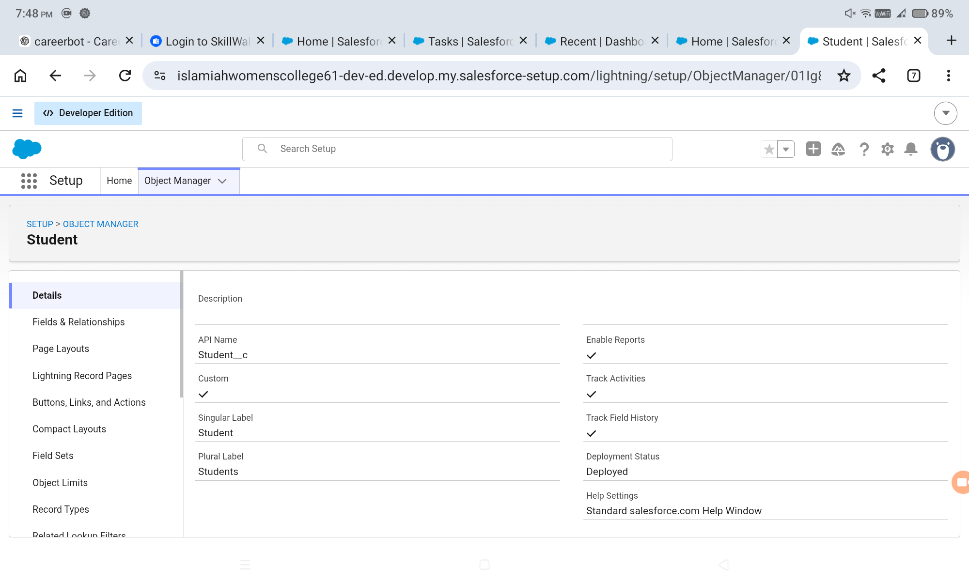

6.2 Student Custom Object
The Student custom object stores core student information, including personal details, contact information, date of birth, address, and student status. It forms one of the primary data entities of SECMS.

Development Process
- Create the Student custom object.
- Set the label as Student and plural label as Students.
- Configure the record name as Student Name.
- Enable appropriate reporting and search options.
- Save the object and verify it in Object Manager.

Expected Result
The configuration should be saved successfully and should be available in the SECMS Salesforce application for the intended users and workflow.

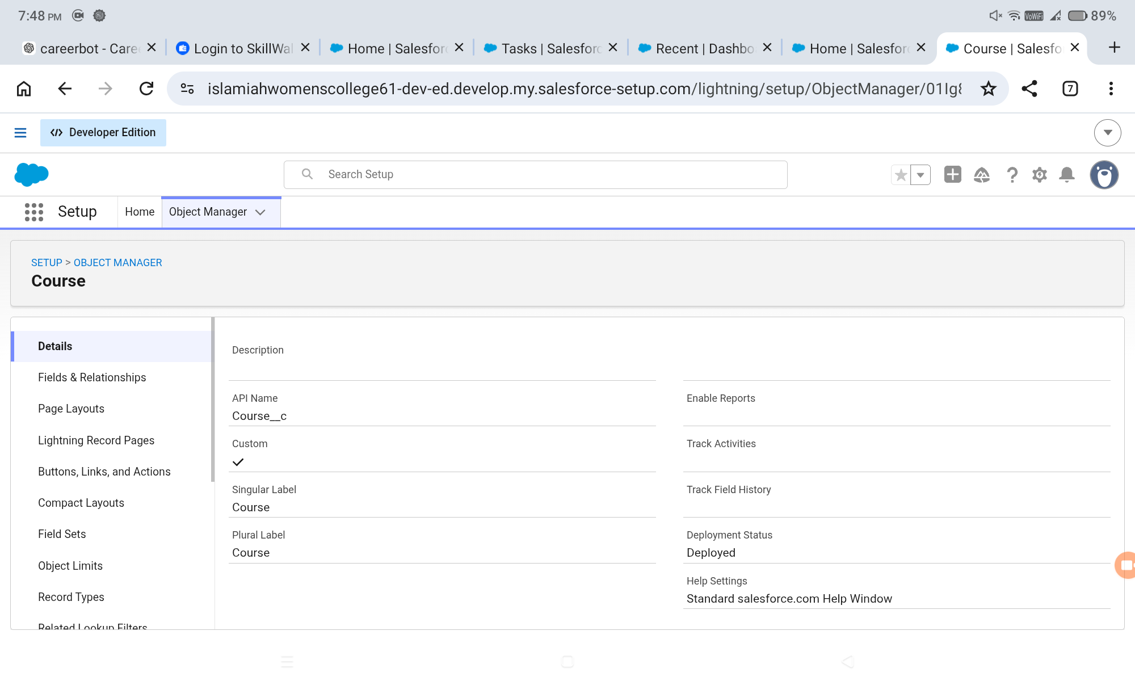6.3 Course Custom Object
The Course custom object represents academic courses offered by the institution. It supports course identification, category, duration, fee, and description information.

Development Process
- Create the Course custom object.
- Configure the course record name.
- Enable required project features.
- Save and verify the Course object.

Expected Result
The configuration should be saved successfully and should be available in the SECMS Salesforce application for the intended users and workflow.
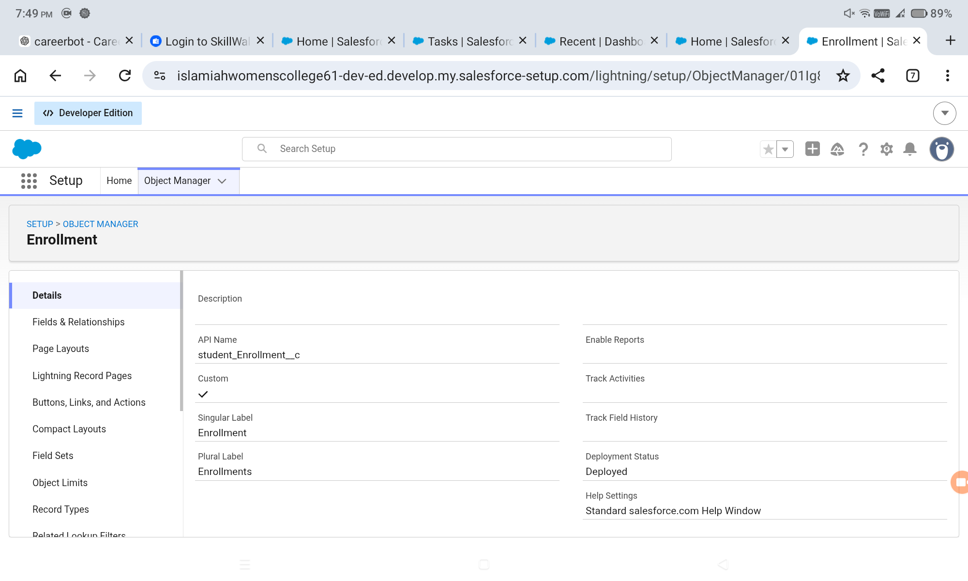

6.4 Enrollment Custom Object
The Enrollment object represents the transaction connecting a student to a course and instructor. It stores enrollment date, status, fee information, total amount, and comments.

Development Process
- Create the Enrollment custom object.
- Configure its record name.
- Enable appropriate reporting and activity features.
- Verify the object in Object Manager.

Expected Result
The configuration should be saved successfully and should be available in the SECMS Salesforce application for the intended users and workflow.

6.5 Instructor Custom Object
The Instructor object stores instructor identity and contact information, including instructor code, expertise, phone, and email.

Development Process
- Create the Instructor custom object.
- Configure the instructor record name.
- Save and verify the object.

Expected Result
The configuration should be saved successfully and should be available in the SECMS Salesforce application for the intended users and workflow.
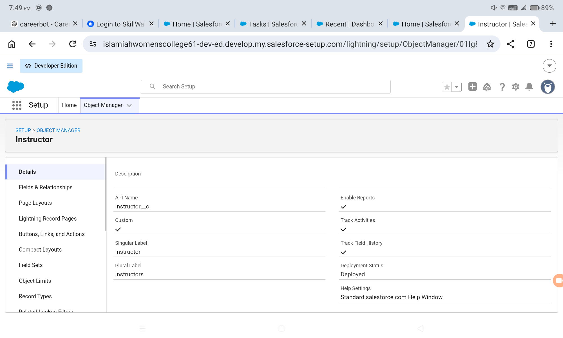

6.6 Student Object Fields
Student fields capture the information required for maintaining a structured student record.

Development Process
- Student Name – standard text record name.
- Email – Email data type.
- Phone – Phone data type.
- Date of Birth – Date data type.
- Student Status – Picklist.
- Address – Text Area.

Expected Result
The configuration should be saved successfully and should be available in the SECMS Salesforce application for the intended users and workflow.
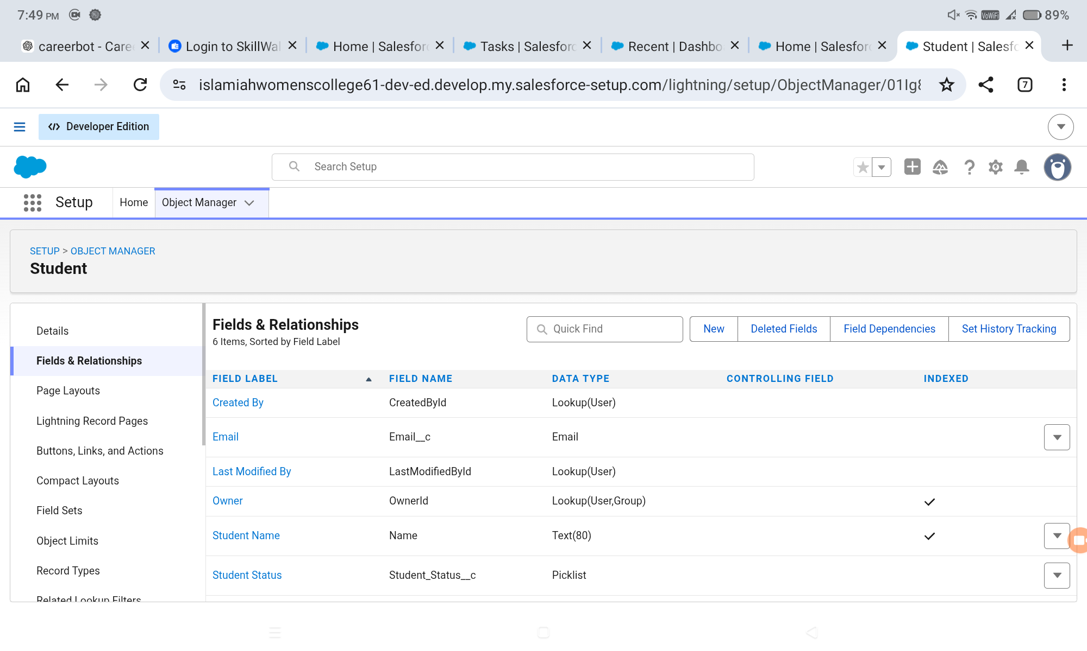

6.7 Course Object Fields
Course fields capture the information needed to describe academic offerings and their fee structure.

Development Process
- Course Name – standard text record name.
- Category – Picklist.
- Duration – Number/Text as configured.
- Course Fee – Currency.
- Description – Text Area.

Expected Result
The configuration should be saved successfully and should be available in the SECMS Salesforce application for the intended users and workflow.
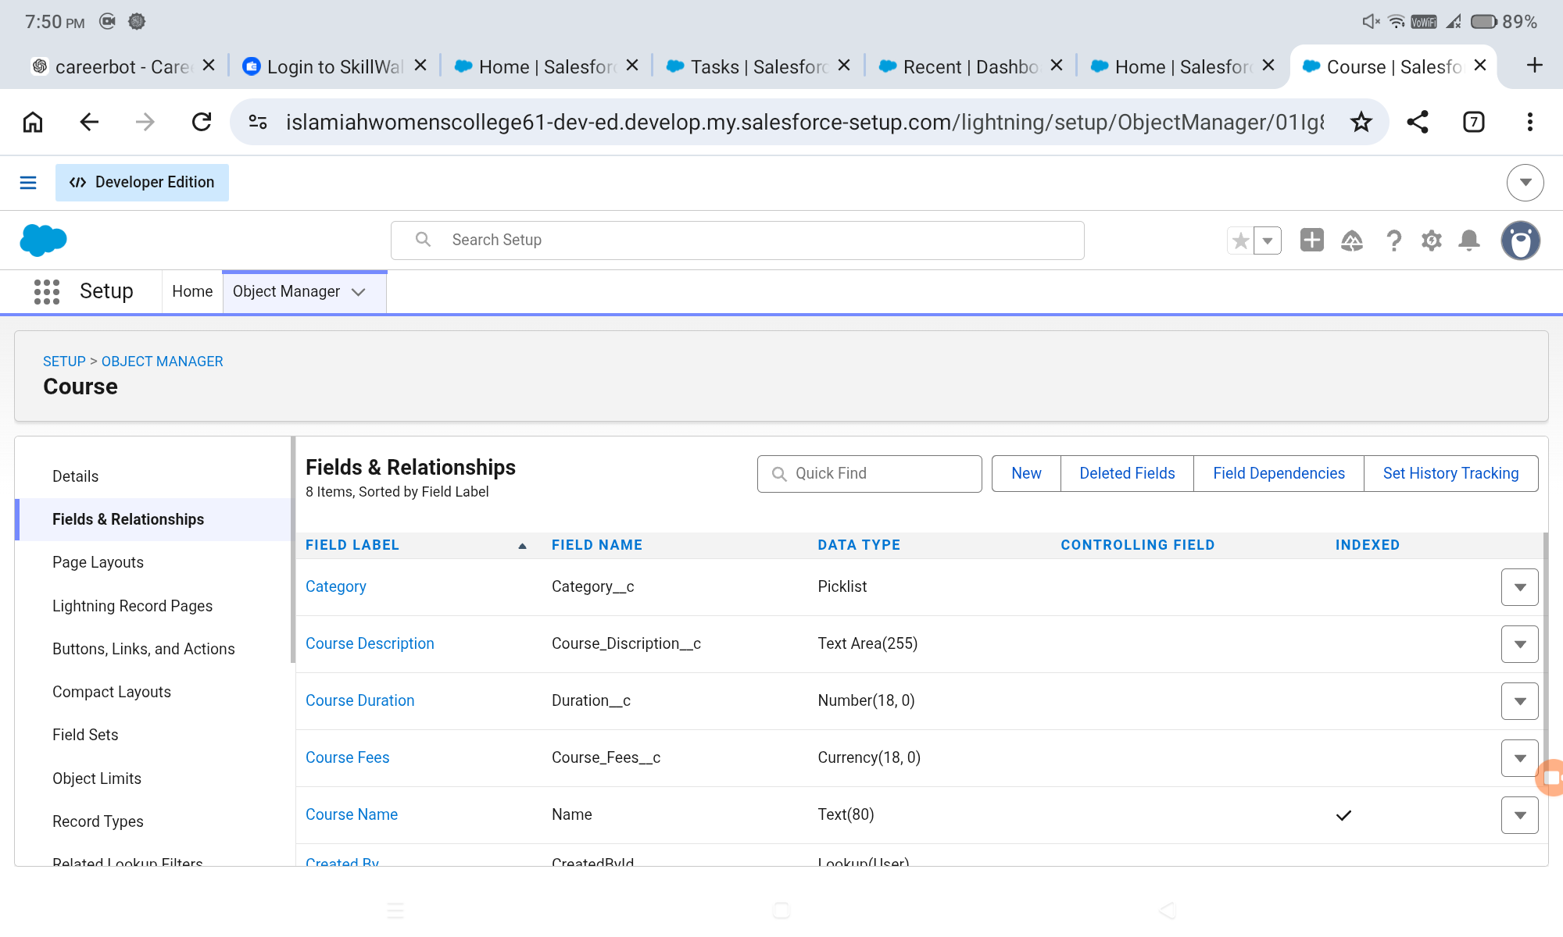

6.8 Instructor Object Fields
Instructor fields provide the identification and contact details needed for instructor assignment and management.

Development Process
- Instructor Name – standard text record name.
- Instructor Code – Text.
- Expertise – Picklist.
- Phone – Phone.
- Email – Email.

Expected Result
The configuration should be saved successfully and should be available in the SECMS Salesforce application for the intended users and workflow.
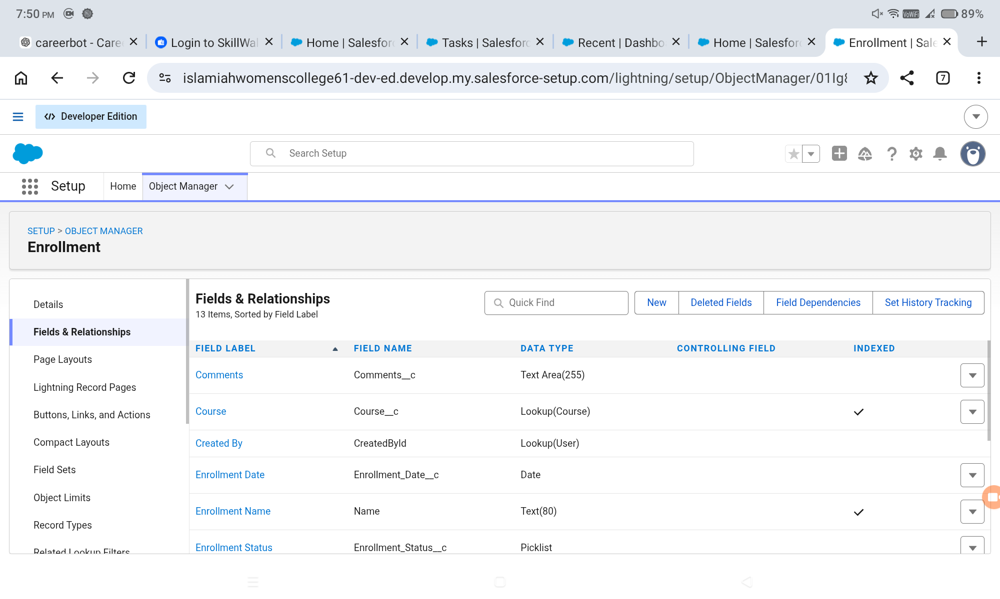

6.9 Enrollment Object Fields
Enrollment fields connect the enrollment transaction to its related records and capture status and fee information.

Development Process
- Student – Lookup to Student.
- Course – Lookup to Course.
- Instructor – Lookup to Instructor.
- Enrollment Date – Date.
- Enrollment Status – Picklist.
- Fees Paid – Checkbox.
- Total Amount – Currency.
- Comments – Text Area.

Expected Result
The configuration should be saved successfully and should be available in the SECMS Salesforce application for the intended users and workflow.
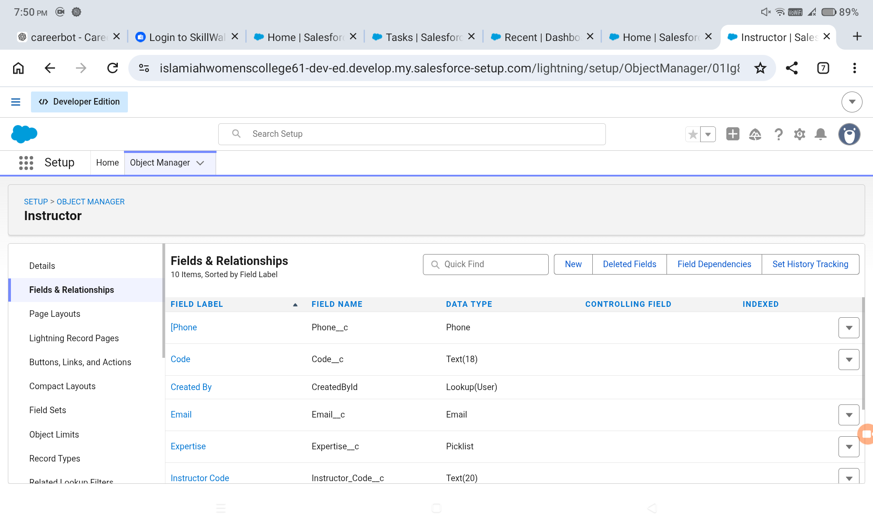

6.10 Enrollment–Student Relationship
A lookup relationship from Enrollment to Student links each enrollment record with the corresponding student.

Development Process
- Open Enrollment fields and relationships.
- Create a Lookup Relationship.
- Select Student as the related object.
- Set the field label to Student.
- Ensure field visibility and layout placement.
- Save and verify the relationship.

Expected Result
The configuration should be saved successfully and should be available in the SECMS Salesforce application for the intended users and workflow.
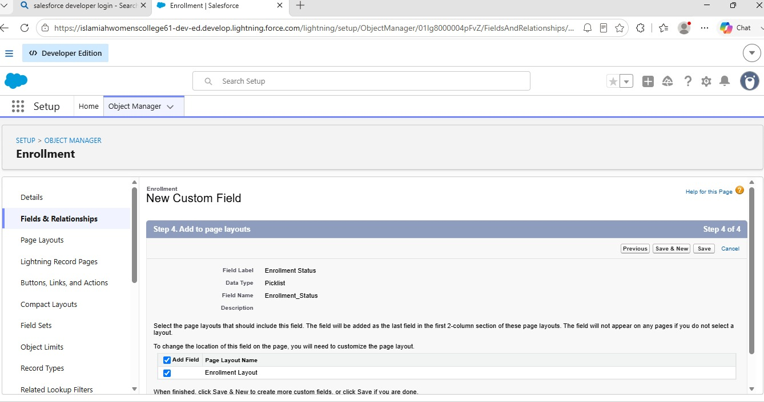

6.11 Enrollment–Course Relationship
The Course lookup connects each enrollment with the academic course selected by the student.

Development Process
- Create a Lookup Relationship on Enrollment.
- Select Course as the related object.
- Set the field label to Course.
- Configure visibility and layout placement.
- Save and verify.

Expected Result
The configuration should be saved successfully and should be available in the SECMS Salesforce application for the intended users and workflow.
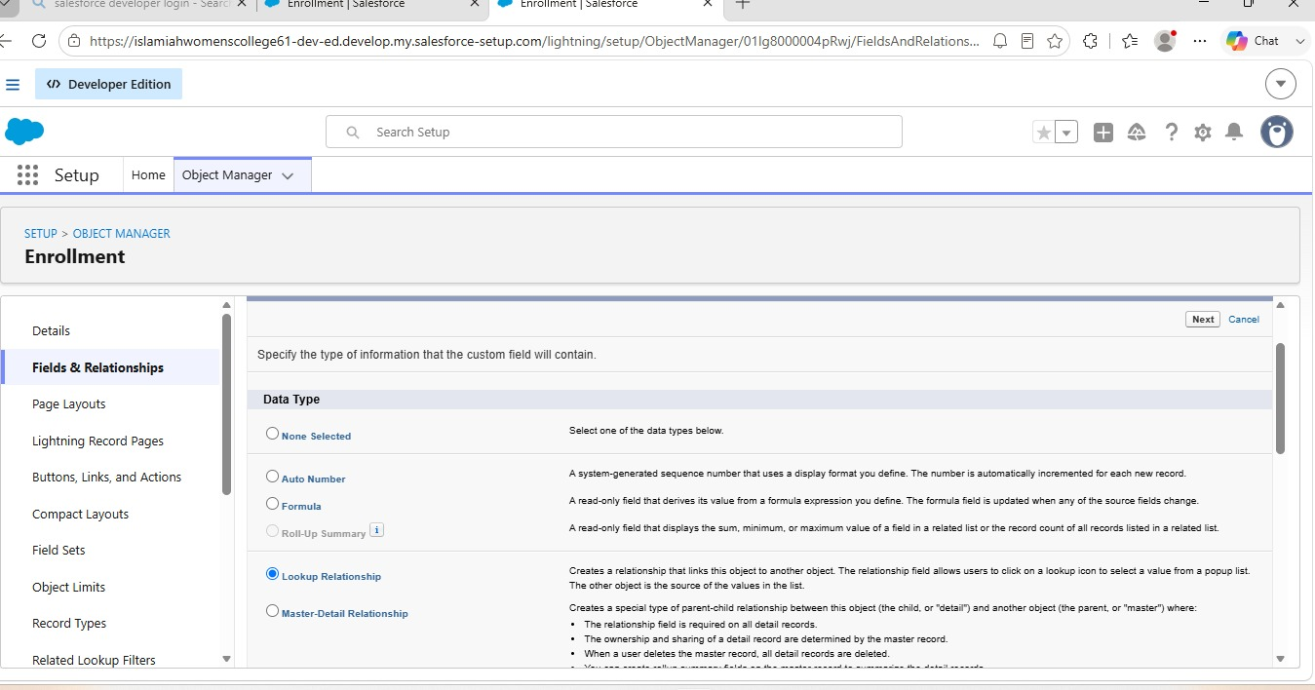

6.12 Enrollment–Instructor Relationship
The Instructor lookup records the instructor associated with an enrollment and supports automatic assignment.

Development Process
- Create a Lookup Relationship on Enrollment.
- Select Instructor as the related object.
- Set the field label to Instructor.
- Configure visibility and layout placement.
- Save and verify.

Expected Result
The configuration should be saved successfully and should be available in the SECMS Salesforce application for the intended users and workflow.
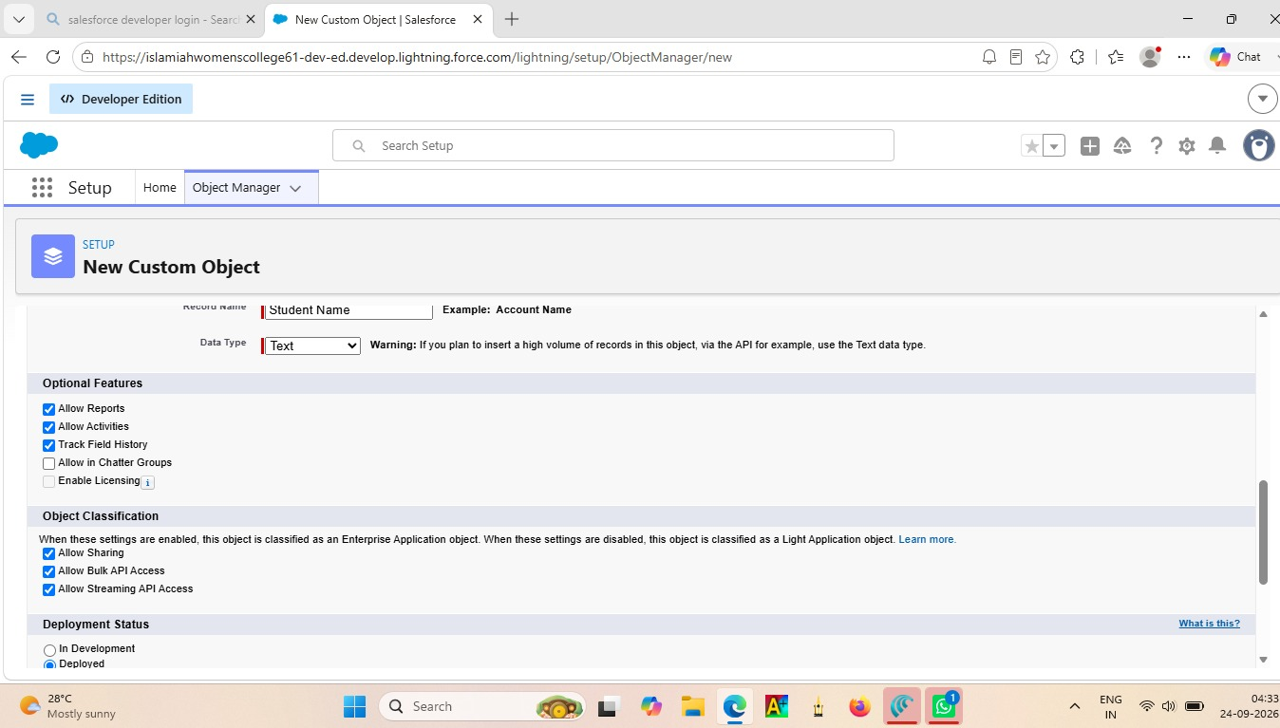

6.13 Tabs Creation
Custom tabs provide direct navigation to the Student, Course, Instructor, and Enrollment objects.

Development Process
- Open Salesforce Setup and locate Tabs.
- Create the Student custom object tab.
- Choose a tab style.
- Assign the tab to appropriate profiles.
- Repeat for Course, Instructor, and Enrollment.

Expected Result
The configuration should be saved successfully and should be available in the SECMS Salesforce application for the intended users and workflow.
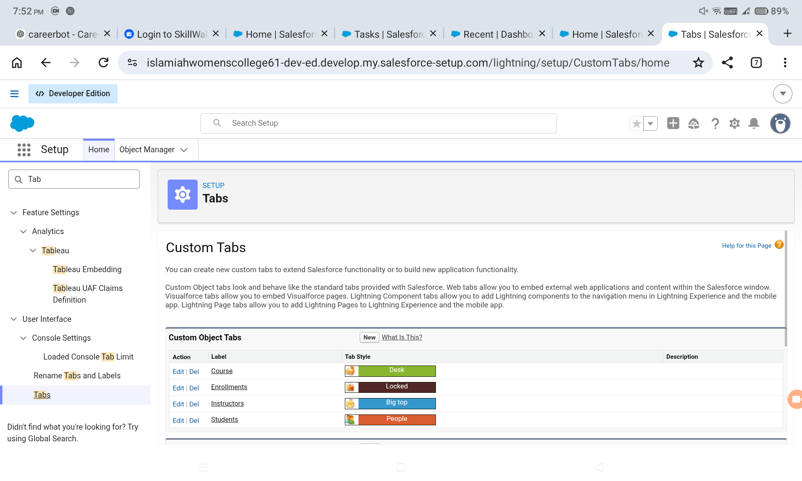

6.14 Remaining Object Tabs
Dedicated tabs for Course, Instructor, and Enrollment make the application easier to navigate and support a consistent Lightning experience.

Development Process
- Create Course tab.
- Create Instructor tab.
- Create Enrollment tab.
- Verify that the tabs are available to the intended profiles.

Expected Result
The configuration should be saved successfully and should be available in the SECMS Salesforce application for the intended users and workflow.

6.15 Lightning App Creation
The Student Enrollment & Course Management Lightning App provides a unified interface for academic operations.

Development Process
- Open App Manager.
- Create a New Lightning App.
- Enter the app name and description.
- Configure navigation style and branding if required.
- Assign the app to relevant profiles.
- Add Student, Course, Instructor, Enrollment, Reports, Dashboards, Home, and Tasks.
- Save and finish.

Expected Result
The configuration should be saved successfully and should be available in the SECMS Salesforce application for the intended users and workflow.
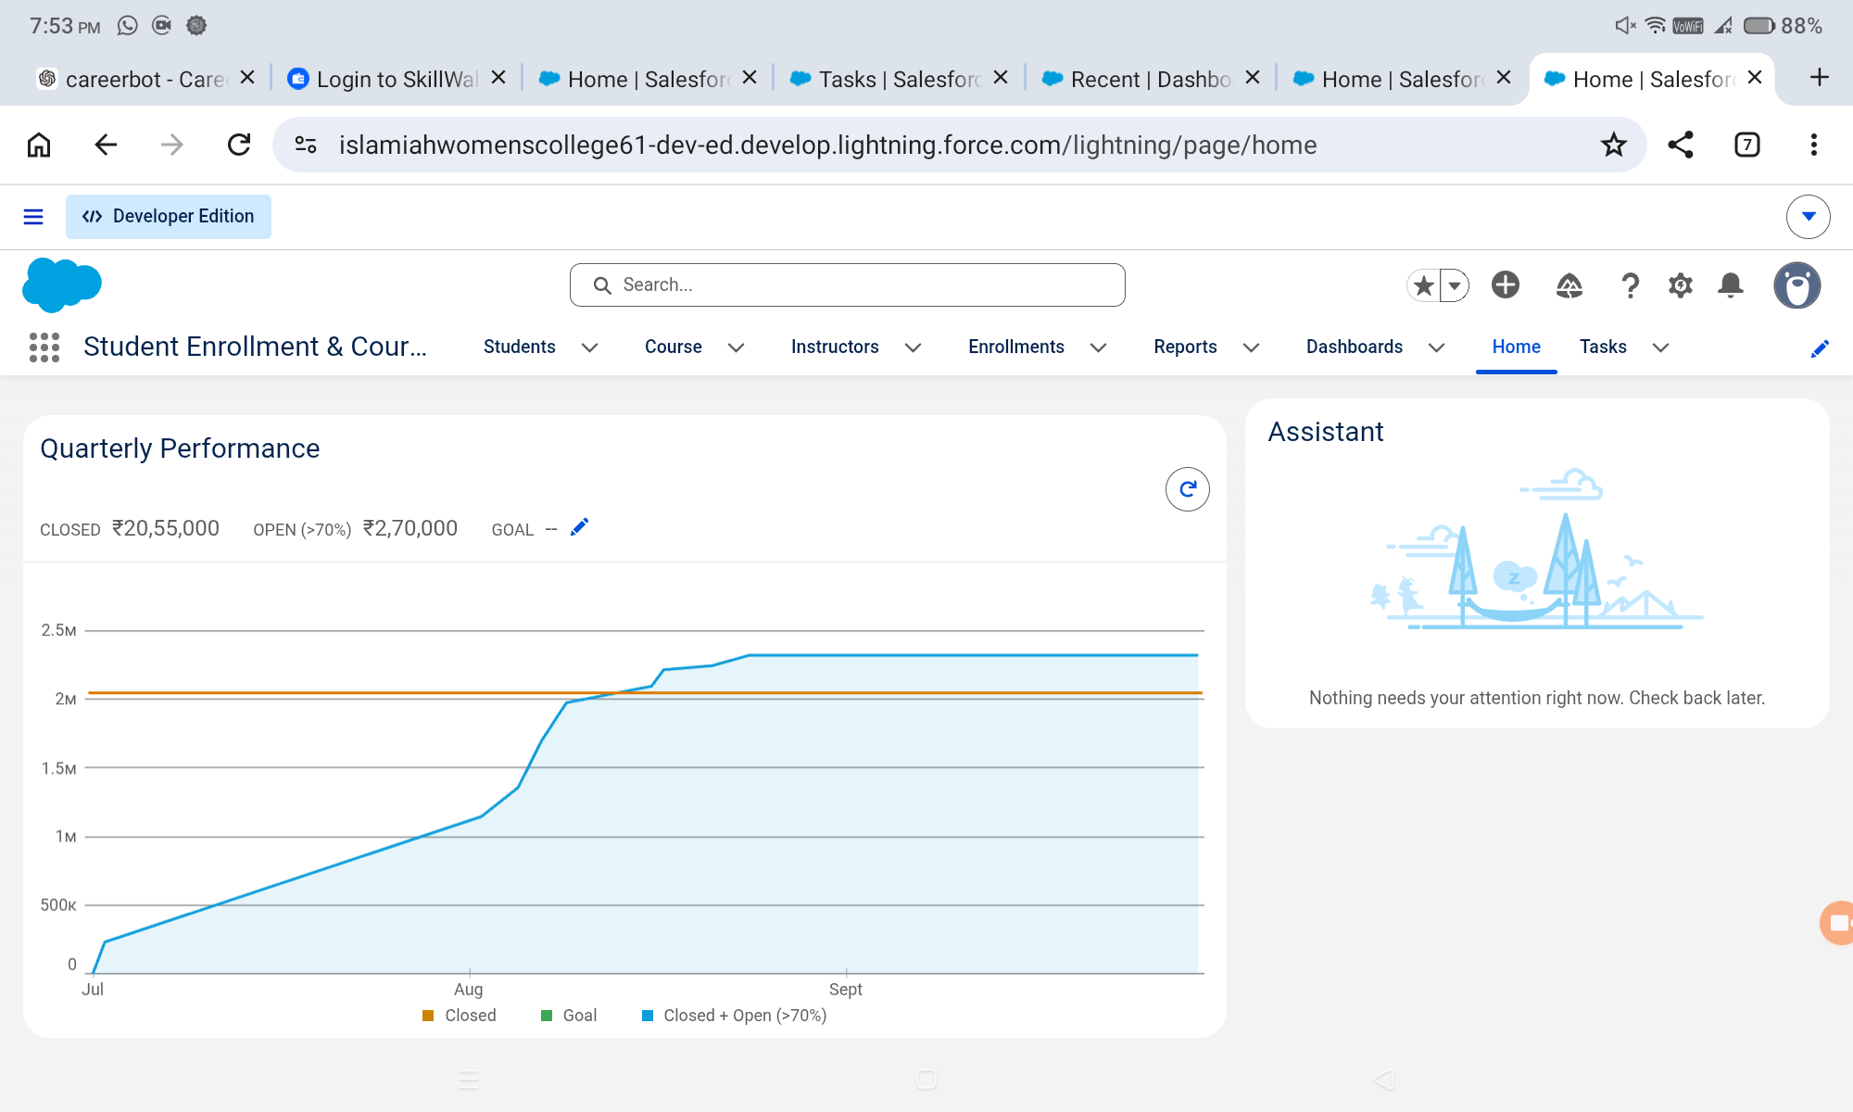

6.16 Lightning App Navigation
The configured navigation menu brings the main academic objects and monitoring tools together in one interface.

Development Process
- Open the completed Lightning App.
- Verify Student, Course, Instructor, Enrollment, Reports, and Dashboards navigation items.
- Confirm that the application opens correctly for the intended profile.

Expected Result
The configuration should be saved successfully and should be available in the SECMS Salesforce application for the intended users and workflow.

6.17 New Enrollment Record Type
The New Enrollment record type separates first-time enrollment processing from re-enrollment processing.

Development Process
- Open Enrollment Object Manager.
- Create a New Enrollment record type using the Master record type as the base.
- Enable it for required profiles.
- Assign the relevant page layout.
- Save.

Expected Result
The configuration should be saved successfully and should be available in the SECMS Salesforce application for the intended users and workflow.
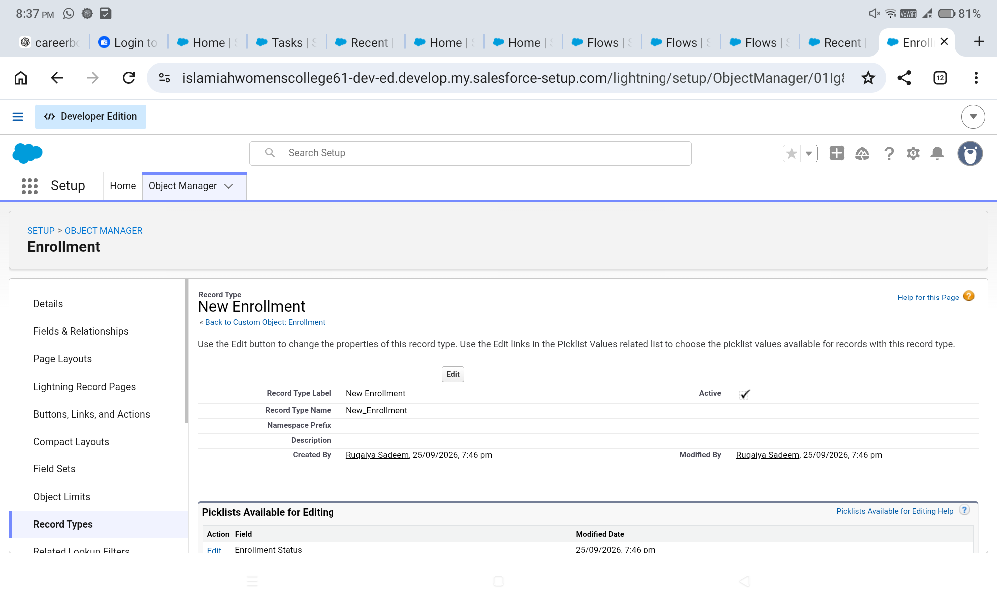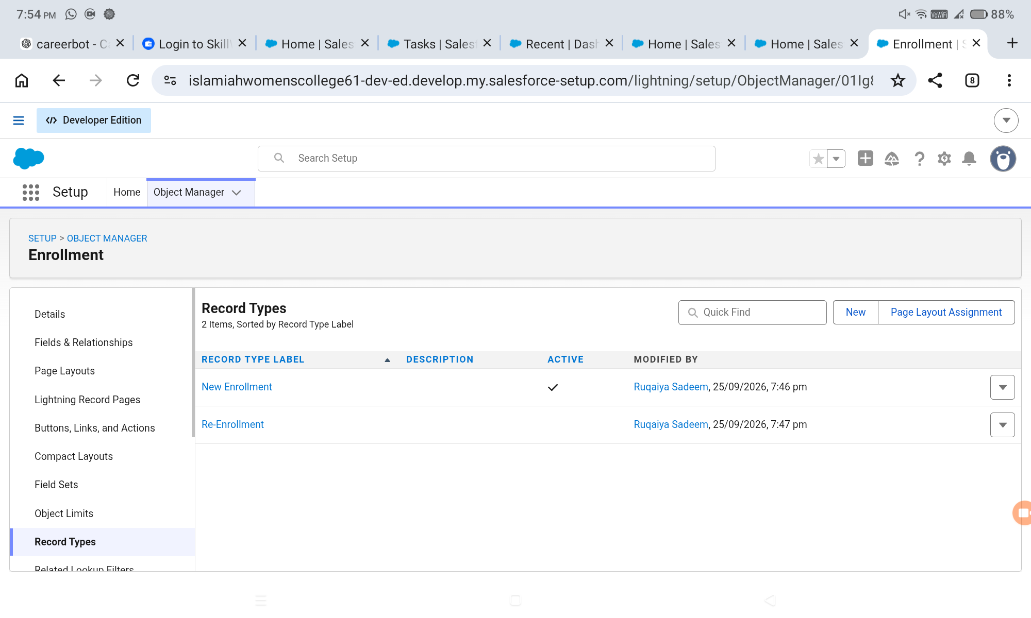

6.18 Re-Enrollment Record Type
The Re-Enrollment record type provides a separate configuration for returning students.

Development Process
- Create the Re-Enrollment record type.
- Enable it for relevant profiles.
- Assign the appropriate layout.
- Save and verify record-type availability.

Expected Result
The configuration should be saved successfully and should be available in the SECMS Salesforce application for the intended users and workflow.
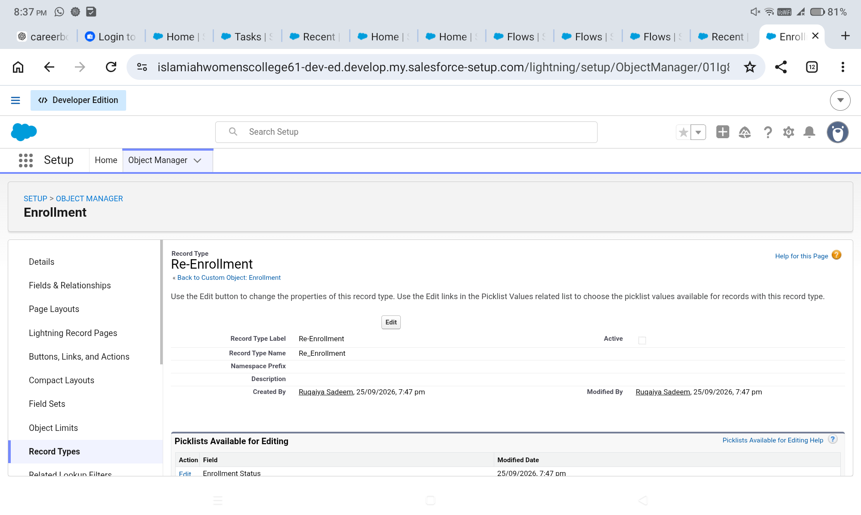

6.19 New Enrollment Page Layout
The New Enrollment layout is configured to display fields relevant to first-time enrollment.

Development Process
- Clone or create the enrollment layout.
- Include Student, Course, Instructor, Enrollment Date, Status, Fees, and related fields.
- Remove fields not required for the new-enrollment process.
- Save and assign the layout.

Expected Result
The configuration should be saved successfully and should be available in the SECMS Salesforce application for the intended users and workflow.
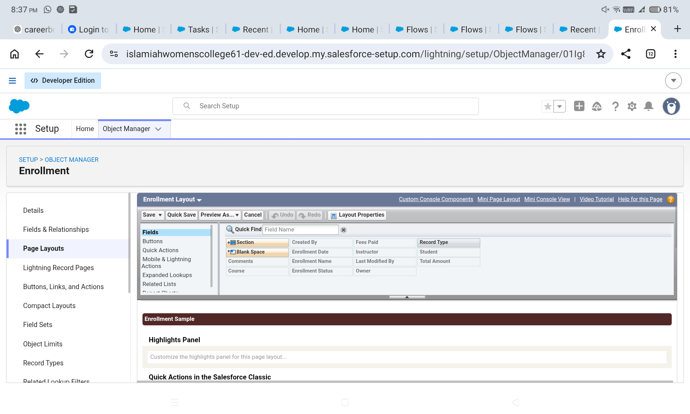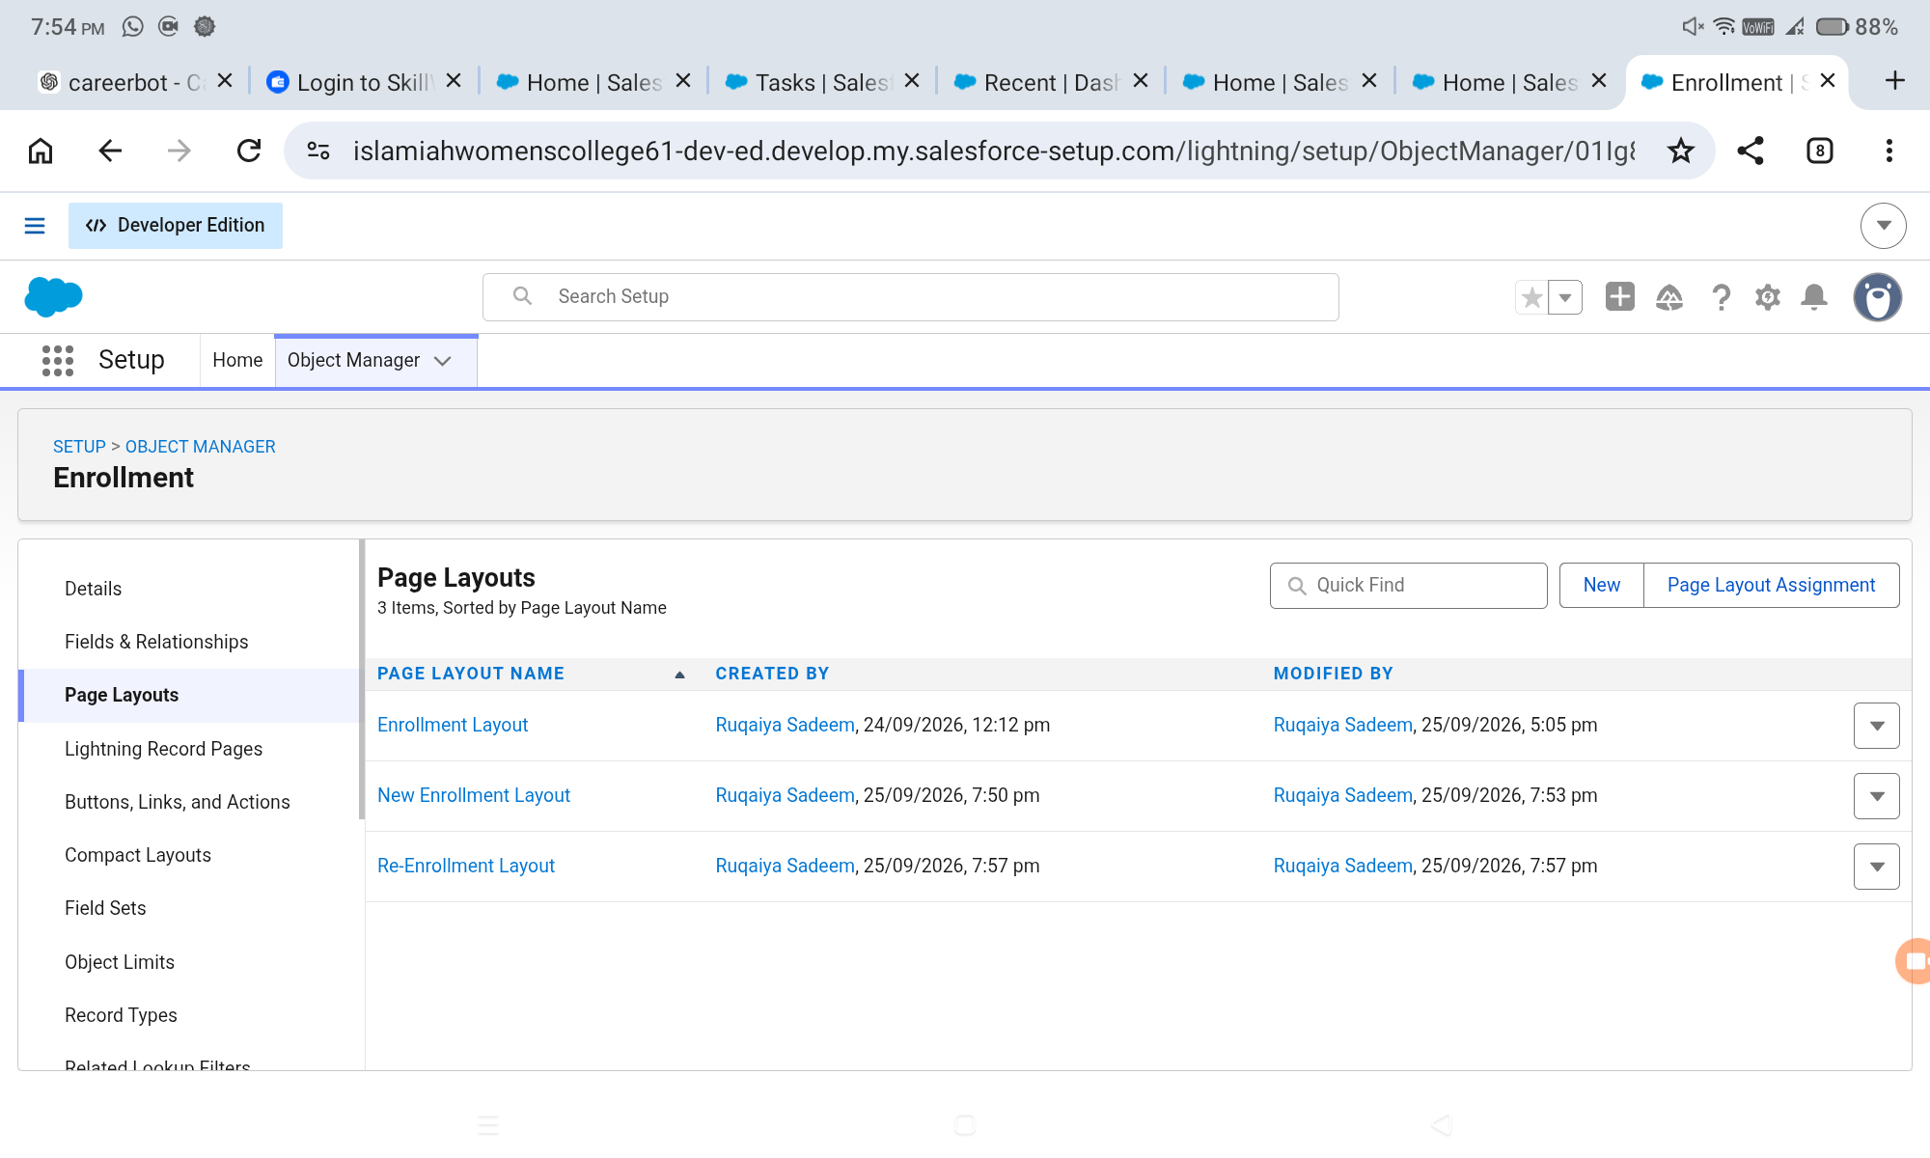

6.20 Re-Enrollment Page Layout
The Re-Enrollment layout provides fields relevant to returning-student processing.

Development Process
- Create the Re-Enrollment layout.
- Include previous-enrollment reference or re-enrollment reason where configured.
- Retain status and fee information.
- Save and assign the layout.

Expected Result
The configuration should be saved successfully and should be available in the SECMS Salesforce application for the intended users and workflow.
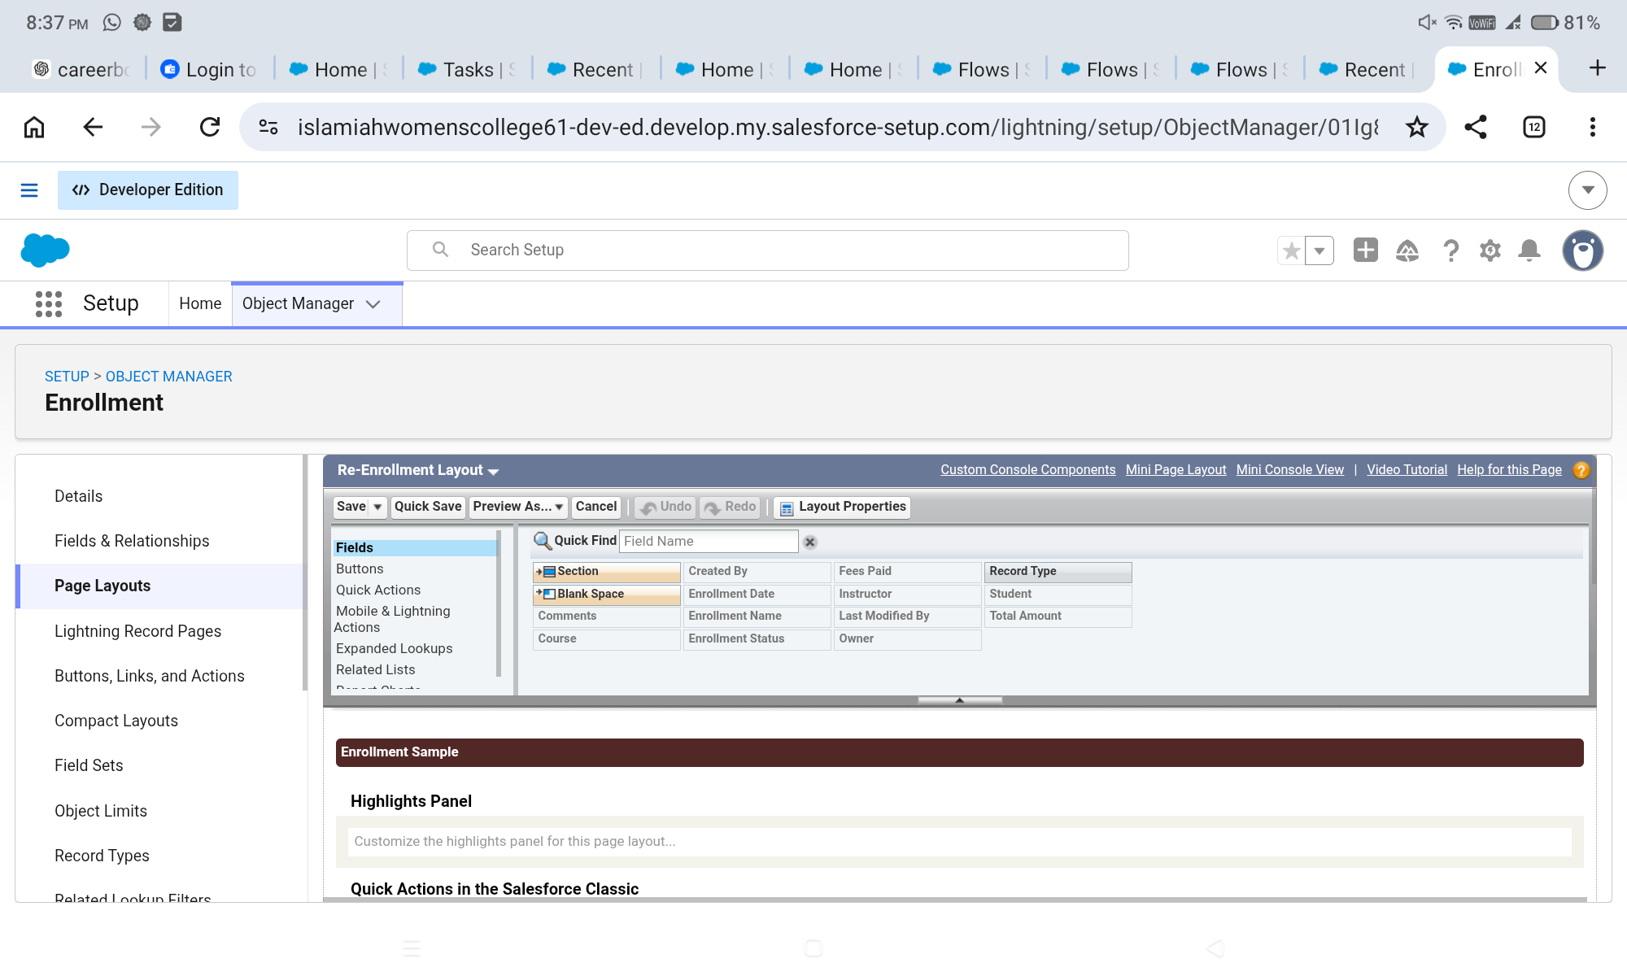

6.21 Student Related List
The Student page layout can display related Enrollment records so that users can see enrollment history from the student record.

Development Process
- Open Student page layout.
- Select Related Lists.
- Add the Enrollments related list.
- Configure columns if required.
- Save.

Expected Result
The configuration should be saved successfully and should be available in the SECMS Salesforce application for the intended users and workflow.

6.22 Course Related List
The Course page layout displays related enrollment records for monitoring course participation.

Development Process
- Open Course page layout.
- Add the Enrollments related list.
- Configure columns.
- Save and verify.

Expected Result
The configuration should be saved successfully and should be available in the SECMS Salesforce application for the intended users and workflow.

6.23 Instructor Related List
The Instructor page layout displays related enrollment records, supporting instructor-level visibility.

Development Process
- Open Instructor page layout.
- Add the Enrollments related list.
- Configure columns.
- Save and verify.

Expected Result
The configuration should be saved successfully and should be available in the SECMS Salesforce application for the intended users and workflow.

6.24 Student Email Validation Rule
The Student Email Domain Validation rule ensures that student email addresses satisfy the defined institutional-domain condition.

Development Process
- Create a validation rule on Student.
- Set the rule name as Student_Email_Domain_Validation.
- Use the configured email-domain condition.
- Enter the validation error message.
- Set the error location.
- Save and test with valid and invalid input.

Expected Result
The configuration should be saved successfully and should be available in the SECMS Salesforce application for the intended users and workflow.
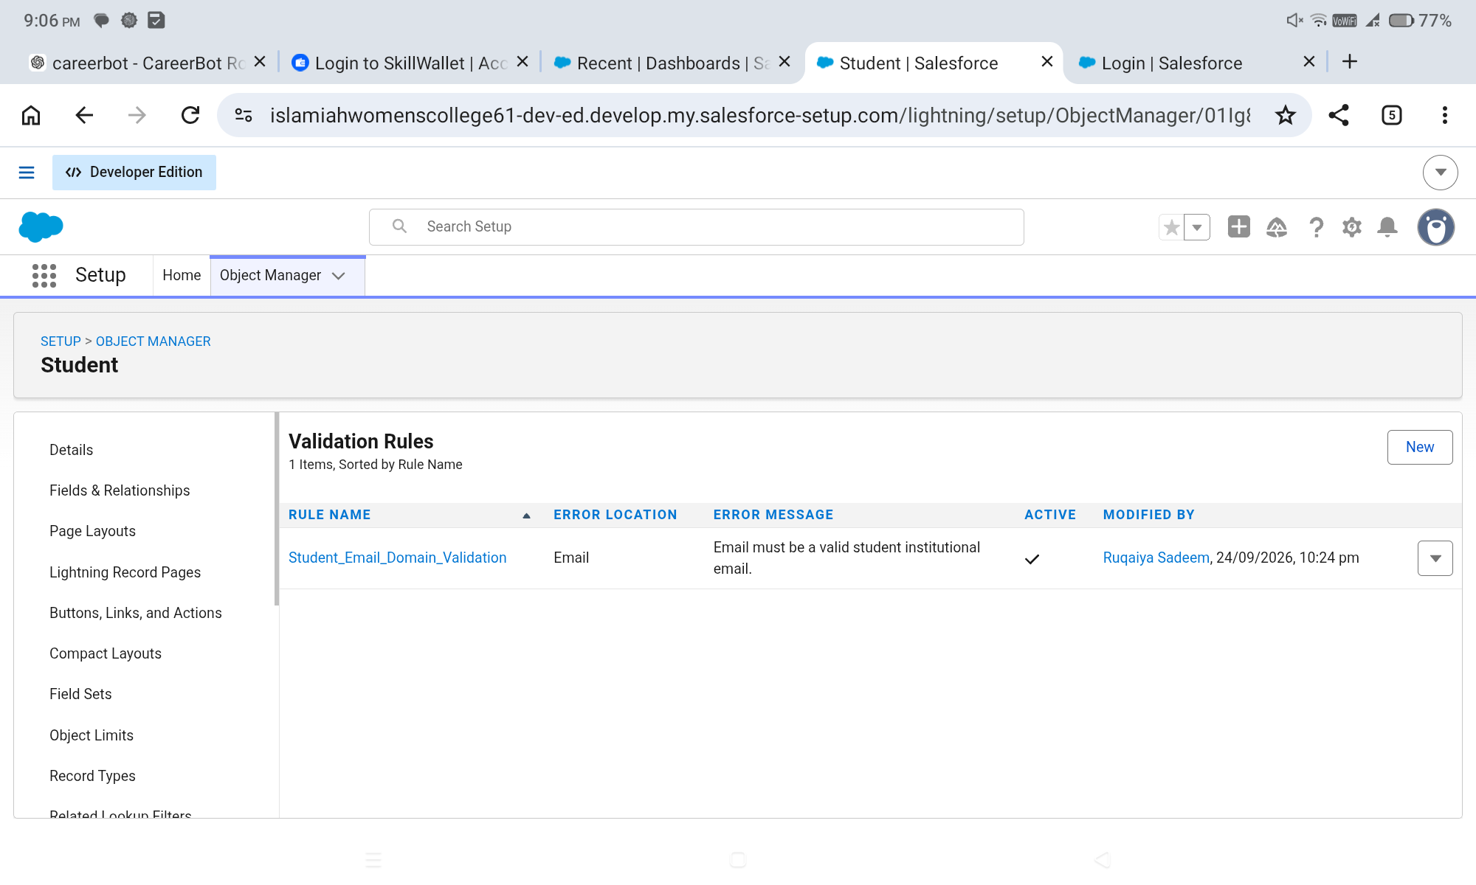

6.25 Fees-Paid Validation Rule
The Fees_Must_Be_Paid_Before_Approval rule prevents an enrollment from being marked Approved when the Fees Paid checkbox is false.

Development Process
- Create the validation rule on Enrollment.
- Set the rule name.
- Use the approval-status and Fees Paid condition.
- Enter the error message.
- Save and test.

Expected Result
The configuration should be saved successfully and should be available in the SECMS Salesforce application for the intended users and workflow.

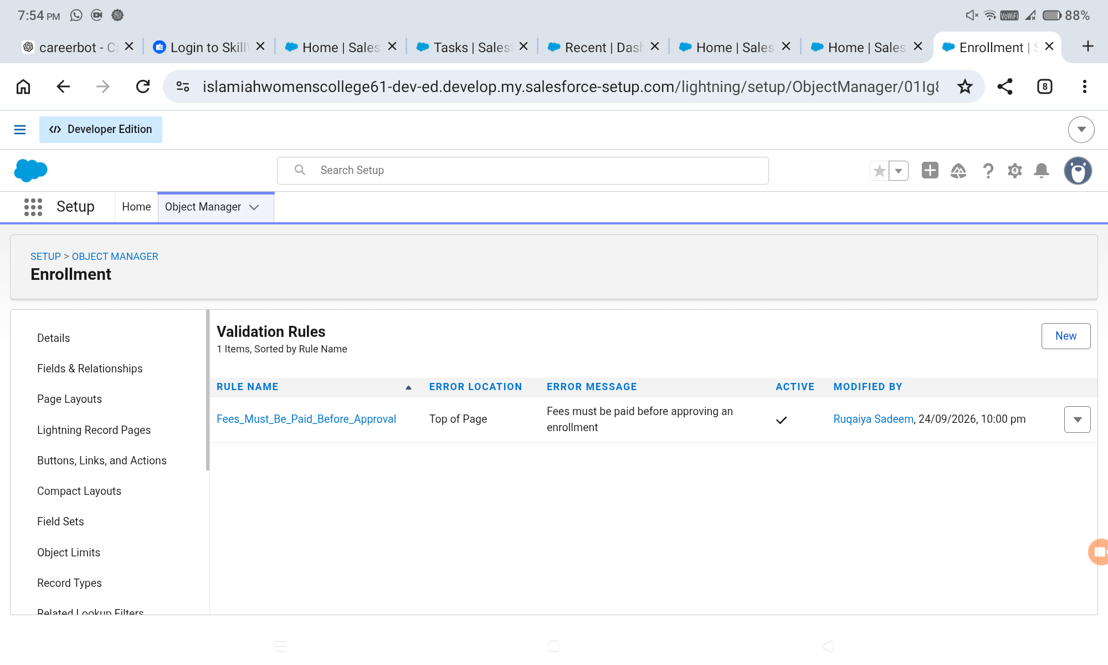

6.26 Enrollment Approval Process
The approval process routes enrollment requests for review by the designated Training Manager or configured approver.

Development Process
- Open Approval Processes for Enrollment.
- Create a new approval process using standard setup.
- Set entry criteria to Enrollment Status = Requested.
- Configure the approval step and approver.
- Configure final actions.
- Activate the process.

Expected Result
The configuration should be saved successfully and should be available in the SECMS Salesforce application for the intended users and workflow.
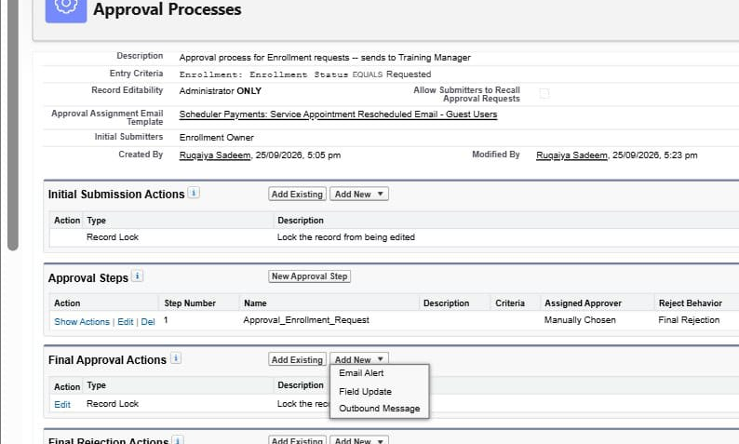

6.27 Final Approval Configuration
When an enrollment is approved, the process updates the Enrollment Status field to Approved.

Development Process
- Configure the final approval field update.
- Set Enrollment_Status__c to Approved.
- Save the final approval action.
- Test with a requested enrollment.

Expected Result
The configuration should be saved successfully and should be available in the SECMS Salesforce application for the intended users and workflow.
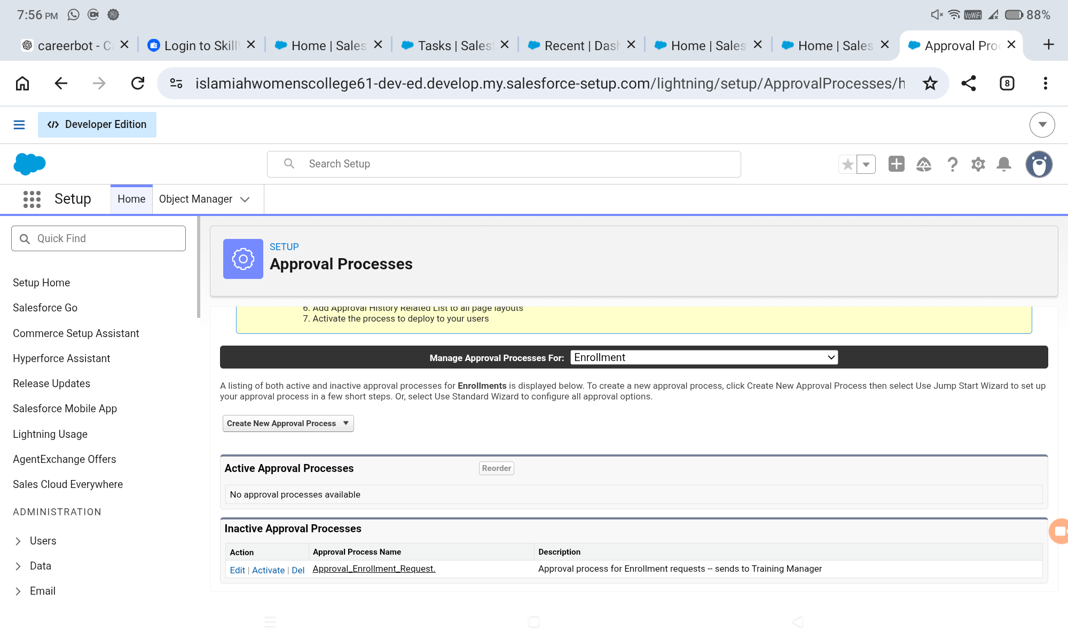

6.29 Enrollment Date Flow
The SetEnrollmentDate record-triggered Flow automatically sets the enrollment date to the current date when an Enrollment record is created.

Development Process
- Create a Record-Triggered Flow on Enrollment.
- Trigger when a record is created.
- Use an Update Records element.
- Set Enrollment_Date__c to $Flow.CurrentDate.
- Save and activate.

Expected Result
The configuration should be saved successfully and should be available in the SECMS Salesforce application for the intended users and workflow.
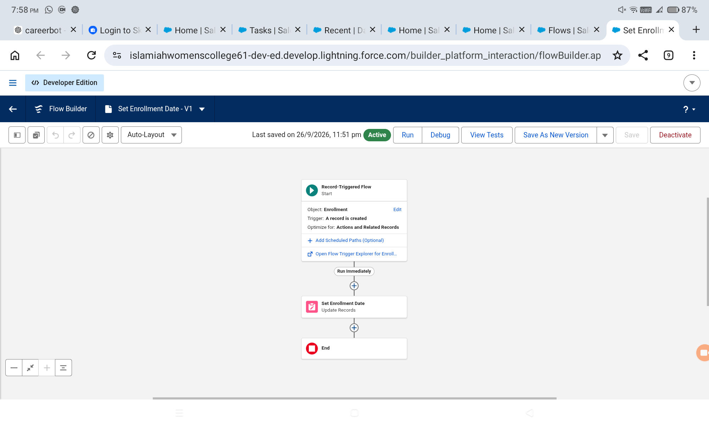

6.30 Enrollment Approval Notification Flow
The Enrollment Approved Action flow supports automated communication and student-status updates after approval.

Development Process
- Create a record-triggered Flow on Enrollment update.
- Set the condition to Enrollment Status = Approved.
- Retrieve the related Student record.
- Use an Email Alert to notify the student.
- Optionally notify the administrator.
- Update the student's status to Active.
- Save and activate.

Expected Result
The configuration should be saved successfully and should be available in the SECMS Salesforce application for the intended users and workflow.
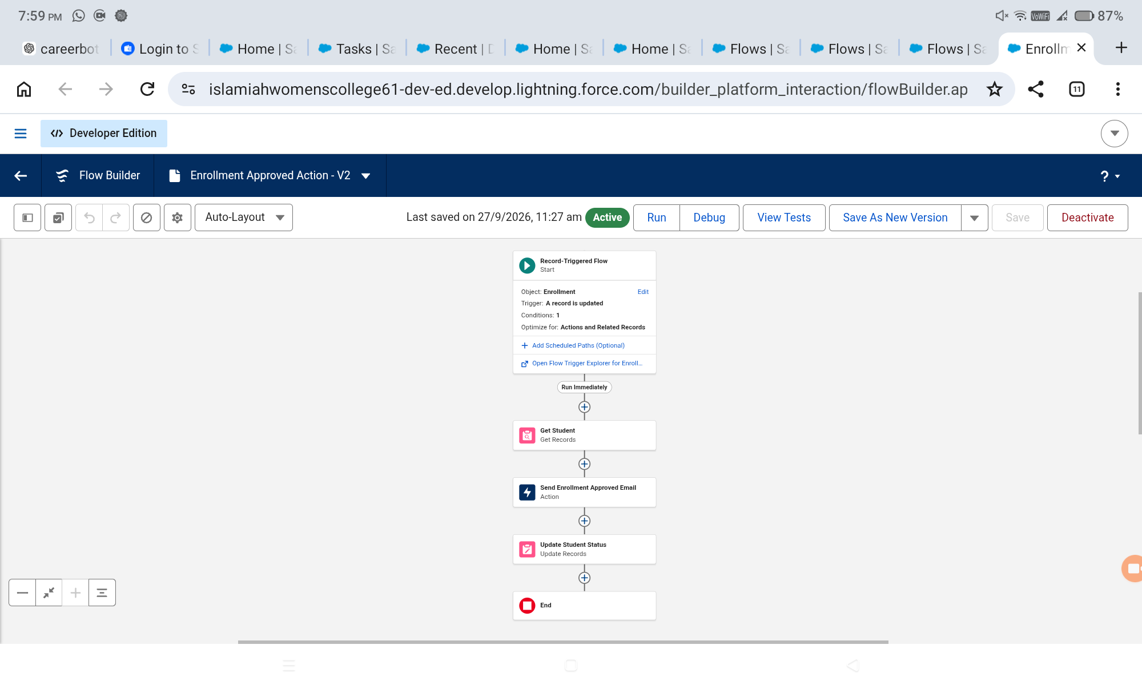

6.31 Instructor Assignment Flow
The AutoAssign_Instructor Flow assigns instructors based on the Course category.

Development Process
- Prepare instructor records and codes.
- Create a record-triggered Flow on Enrollment.
- Retrieve the related Course record.
- Use a Decision element for Technical, Language, and Non-Technical categories.
- Retrieve the corresponding instructor.
- Update the Enrollment Instructor lookup.
- Save and activate.

Expected Result
The configuration should be saved successfully and should be available in the SECMS Salesforce application for the intended users and workflow.
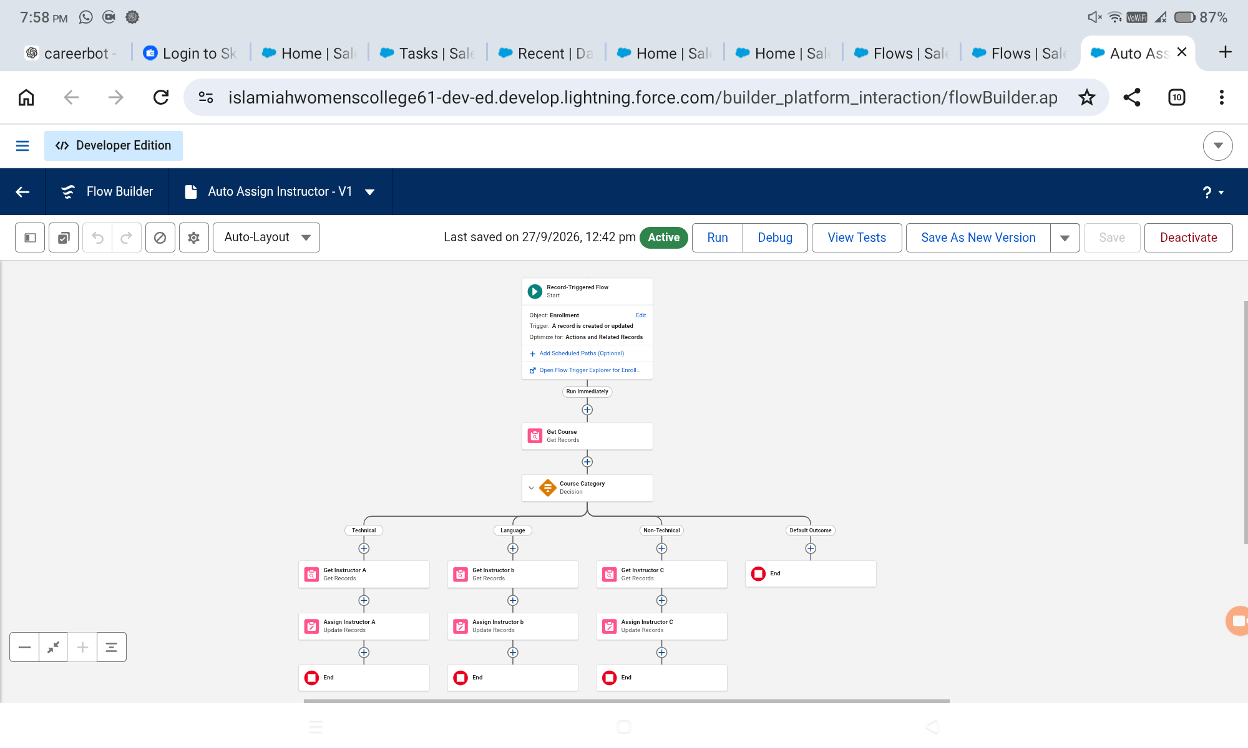

6.32 Follow-Up Task Flow
The Create_Followup_Task Flow creates a follow-up task for an administrator when an enrollment remains in Requested status.

Development Process
- Create a record-triggered Flow on Enrollment.
- Set the condition to Enrollment Status = Requested.
- Retrieve the administrator user.
- Calculate a due date using the configured formula.
- Create a Task with the enrollment as the related record.
- Save and activate.

Expected Result
The configuration should be saved successfully and should be available in the SECMS Salesforce application for the intended users and workflow.

6.33 Students by Status Report
This report groups student records by Student Status and provides a simple view of student-status distribution.

Development Process
- Create a Students report.
- Group rows by Status.
- Add Name, Email, Phone, and other required columns.
- Save as Students by Status.
- Verify the generated results.

Expected Result
The configuration should be saved successfully and should be available in the SECMS Salesforce application for the intended users and workflow.
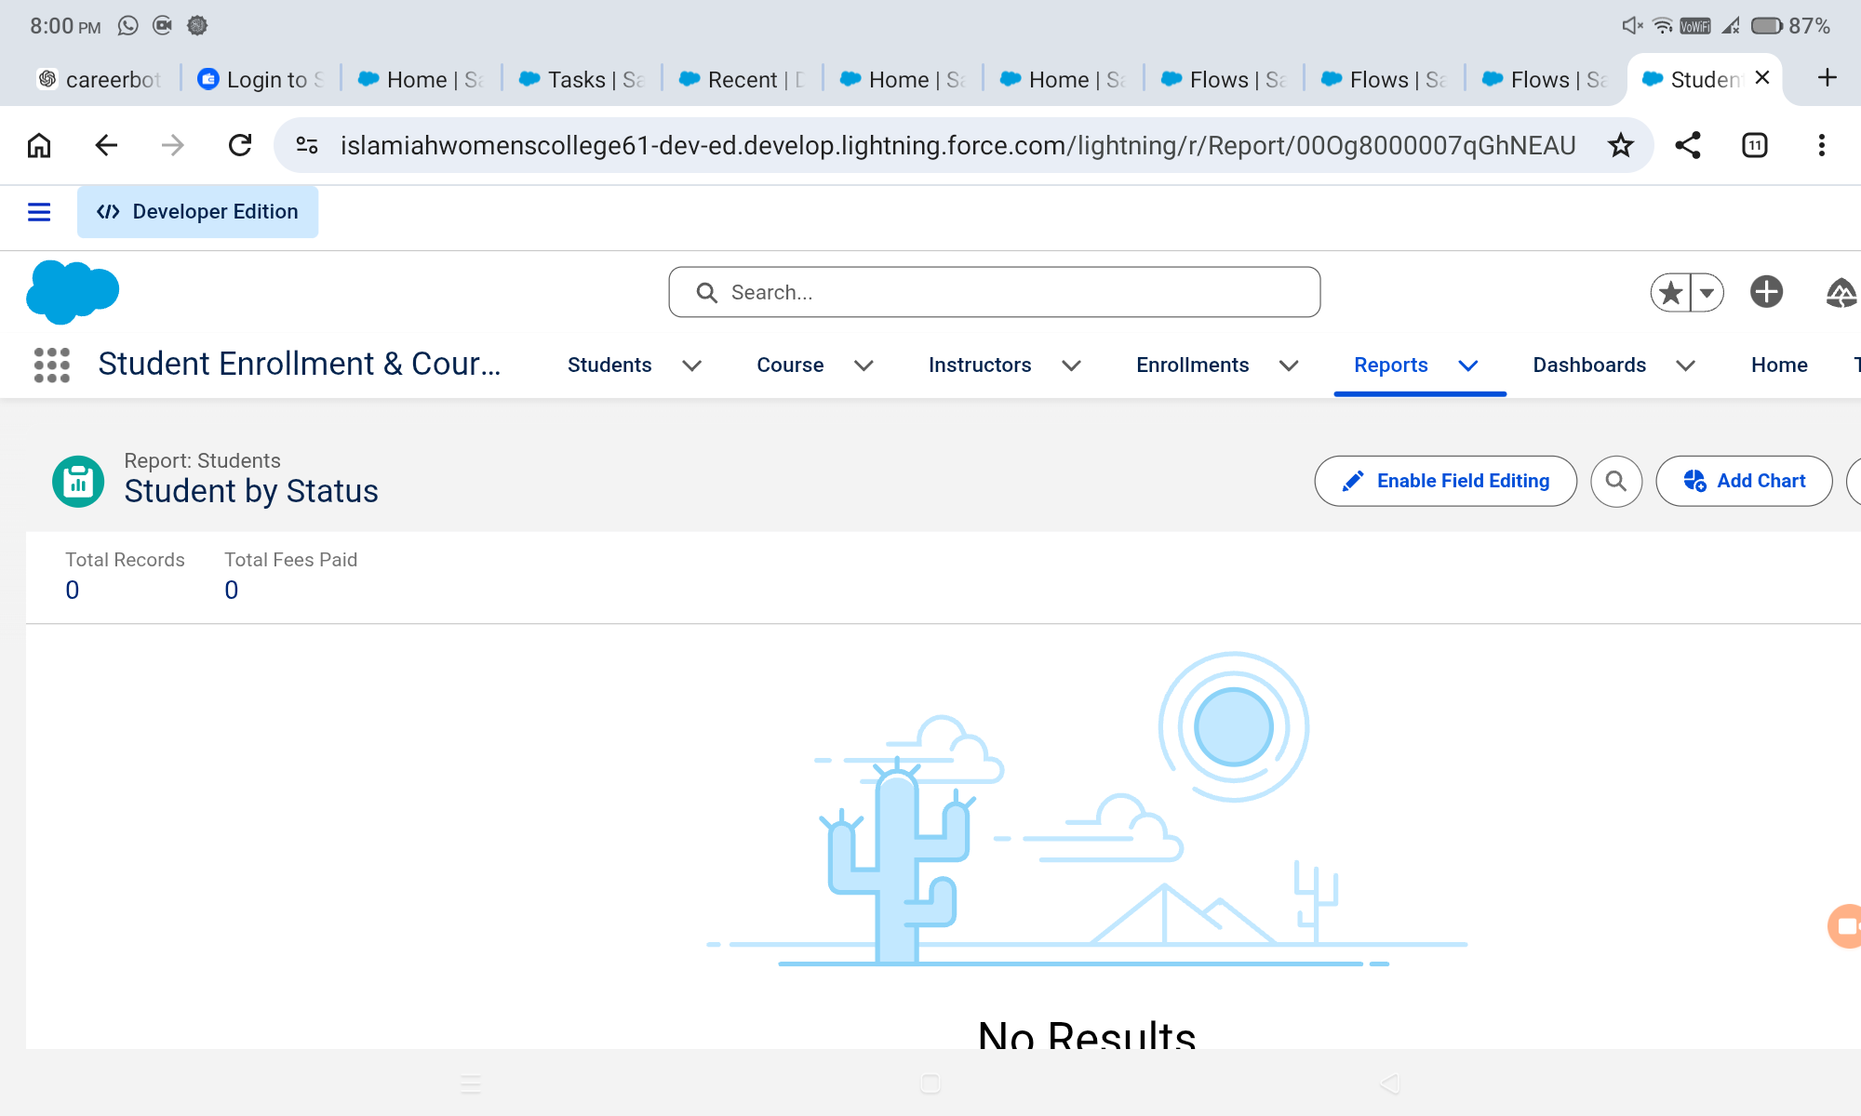

6.34 Enrollments by Course Report
This report groups enrollment records by course and displays the number of enrollments for each course.

Development Process
- Create an Enrollments report.
- Group rows by Course.
- Display record count per course.
- Save as Enrollments by Course.
- Verify results.

Expected Result
The configuration should be saved successfully and should be available in the SECMS Salesforce application for the intended users and workflow.
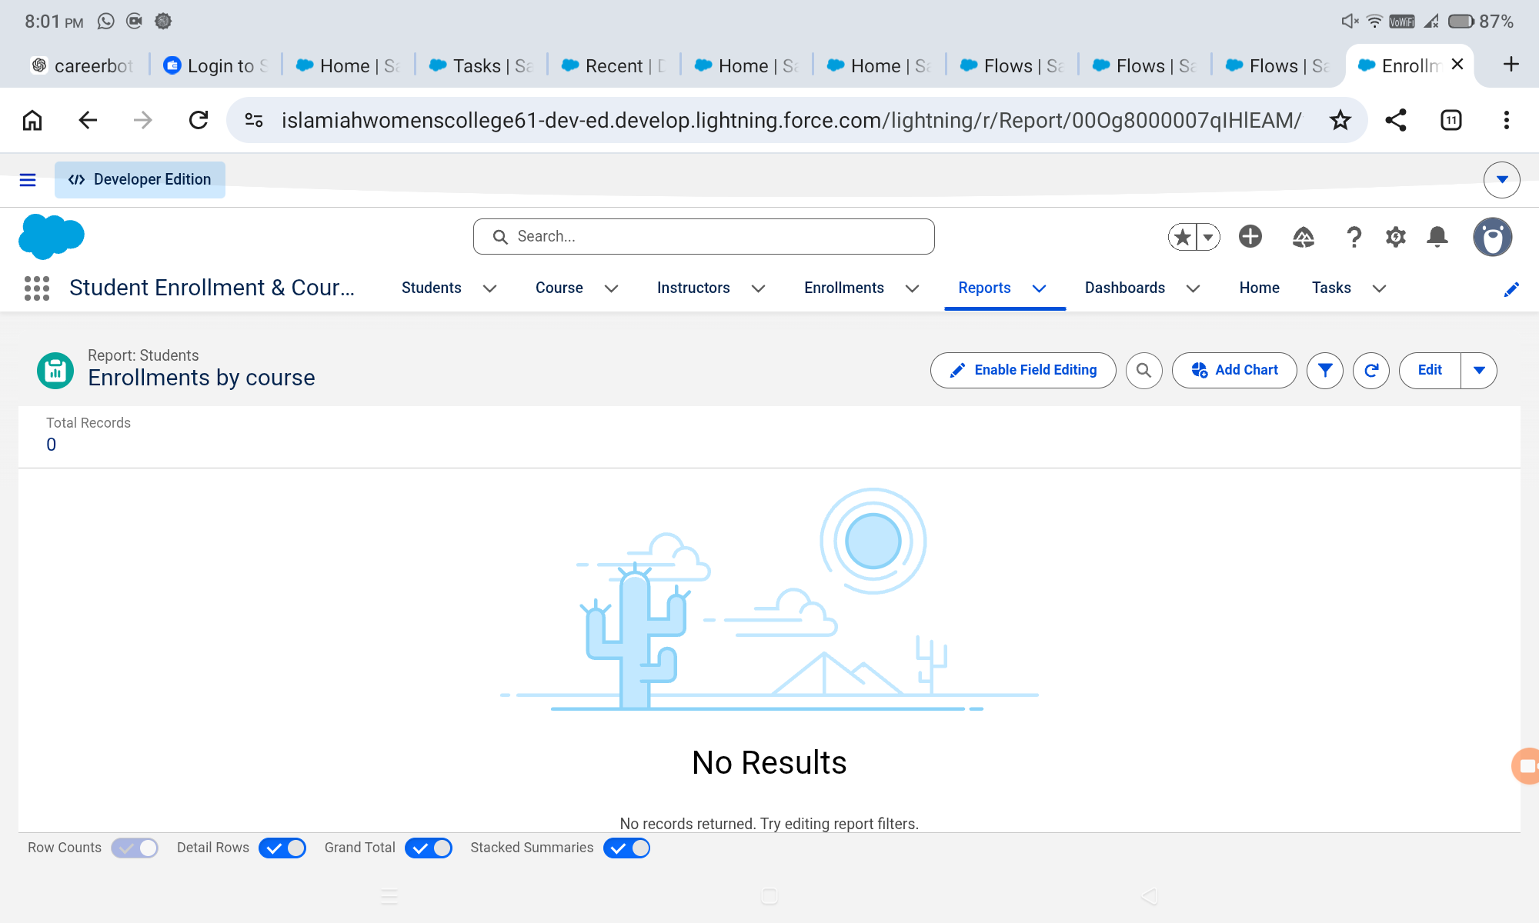

6.35 Pending Enrollment Approvals Report
The Pending Enrollment Approvals report identifies enrollment records that are currently in Requested status.

Development Process
- Create an Enrollments report.
- Filter Enrollment Status = Requested.
- Add Student, Course, Owner, and Created Date columns.
- Save the report.
- Verify pending records.

Expected Result
The configuration should be saved successfully and should be available in the SECMS Salesforce application for the intended users and workflow.
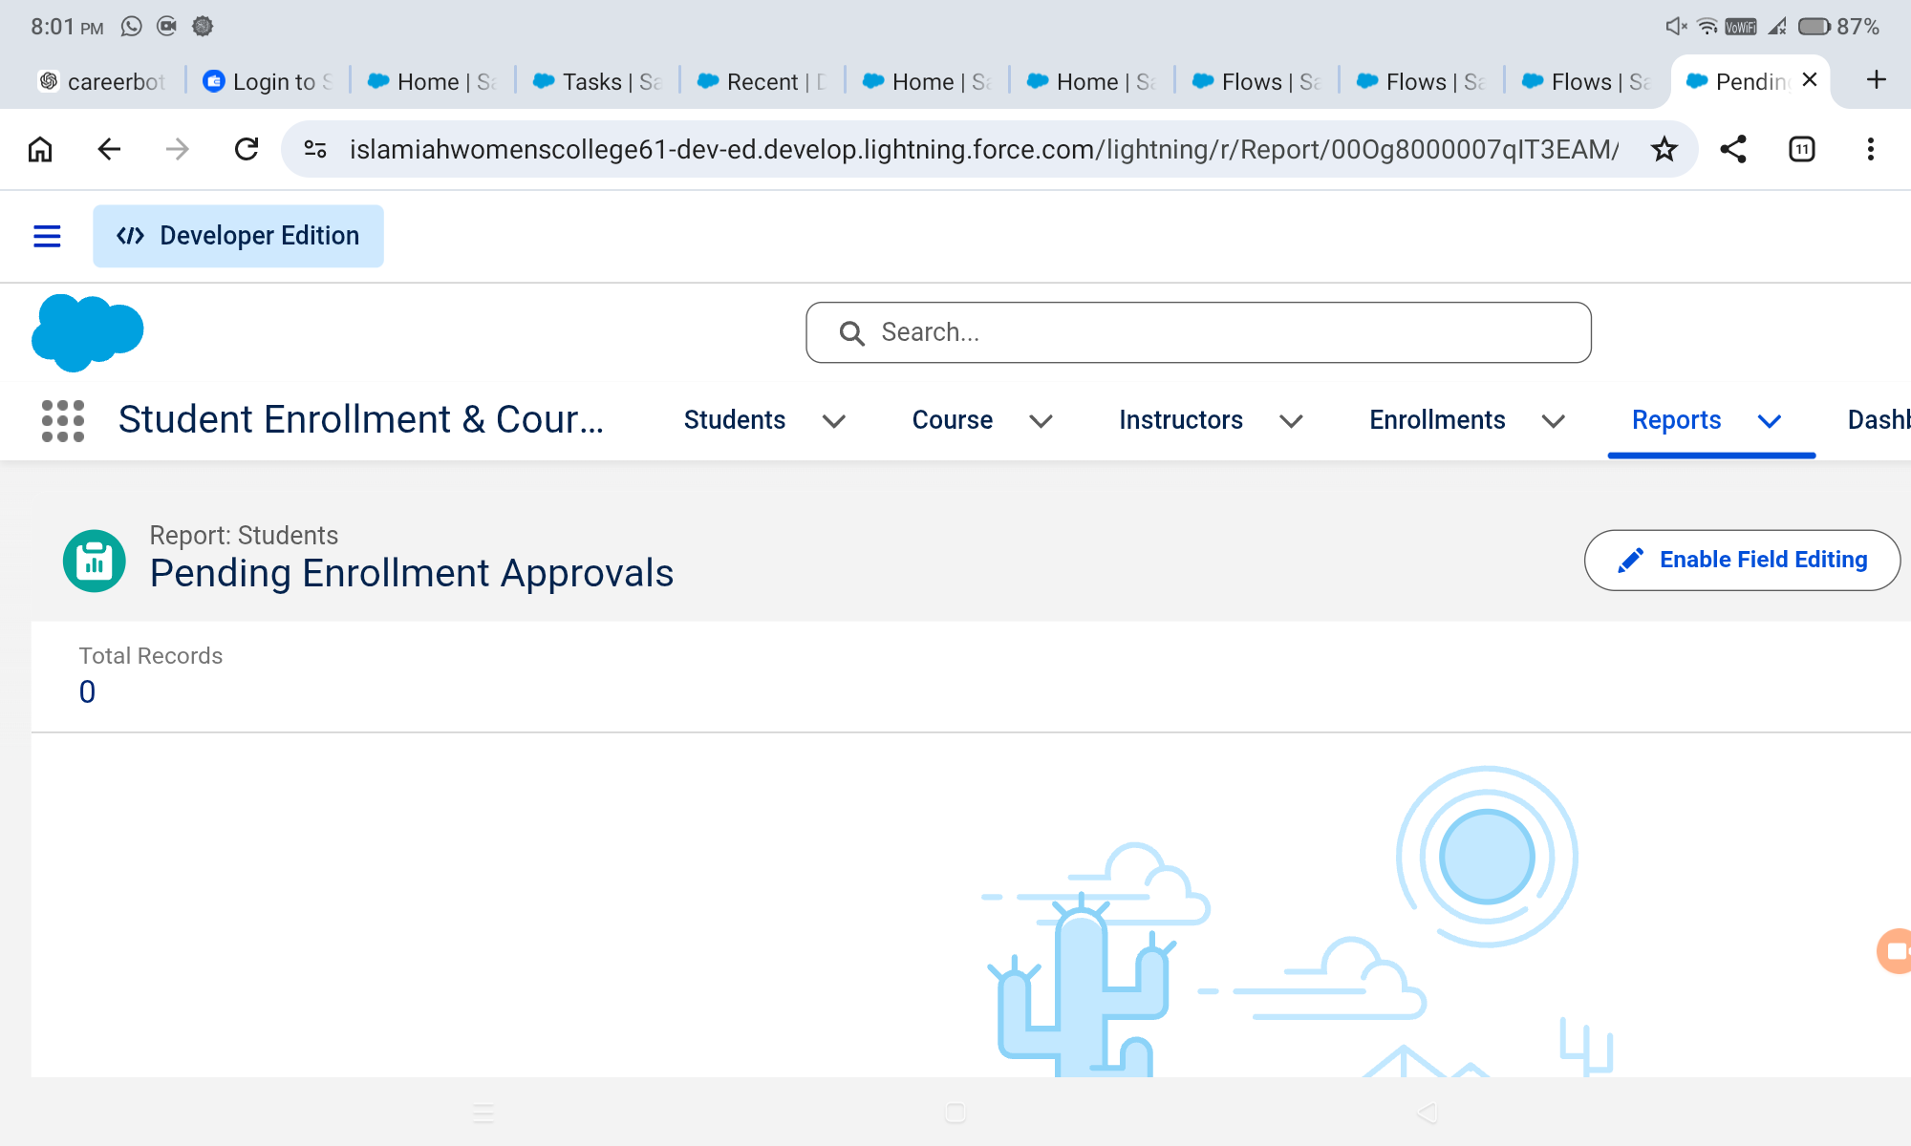

6.36 Revenue Report
The Revenue Report – Fees Paid summarizes enrollments where the Fees Paid field is true and can summarize course-fee values by course.

Development Process
- Create an Enrollments report.
- Filter Fees Paid = TRUE.
- Group by Course.
- Summarize the configured course-fee or revenue field.
- Save and verify.

Expected Result
The configuration should be saved successfully and should be available in the SECMS Salesforce application for the intended users and workflow.
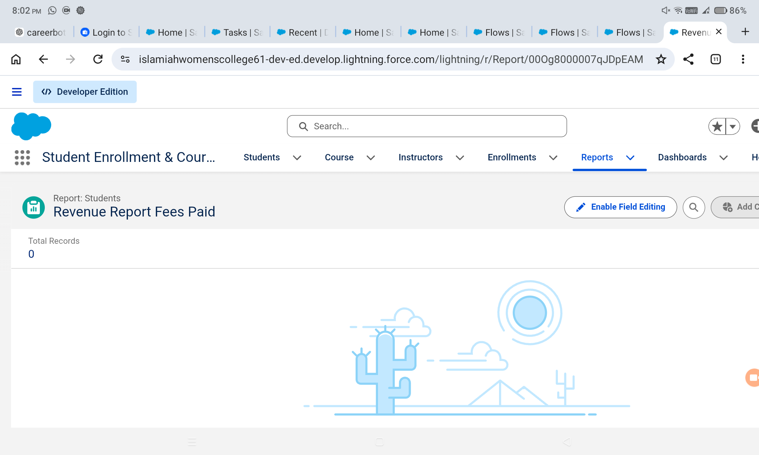

6.37 Student Management Dashboard
The Student Management Dashboard provides visual monitoring using the reports created for the application.

Development Process
- Create the dashboard.
- Add a donut chart using Students by Status.
- Add a bar chart using Enrollments by Course.
- Add a gauge using the Revenue Report.
- Add a table using Pending Enrollment Approvals.
- Arrange and save the components.

Expected Result
The configuration should be saved successfully and should be available in the SECMS Salesforce application for the intended users and workflow.
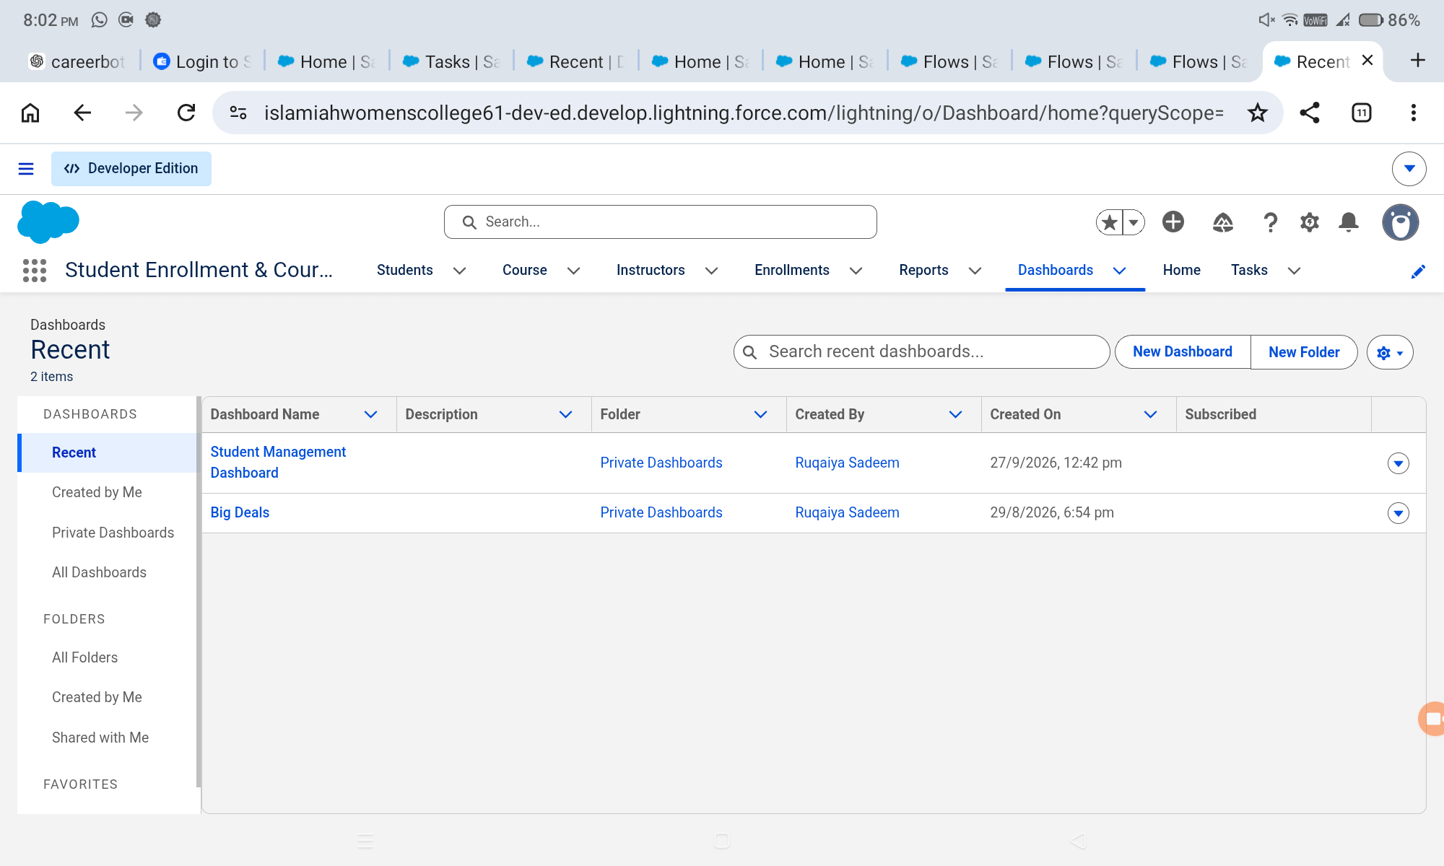

6.38 Profiles and Role-Based Access
Profiles define baseline access to objects and records for administrators, enrollment officers, and instructors.

Development Process
- Configure an Admin profile with broad project access.
- Configure Enrollment Officer access for enrollment creation and updates.
- Configure Instructor access for relevant enrollment visibility.
- Review object permissions and field visibility.
- Save and test.

Expected Result
The configuration should be saved successfully and should be available in the SECMS Salesforce application for the intended users and workflow.
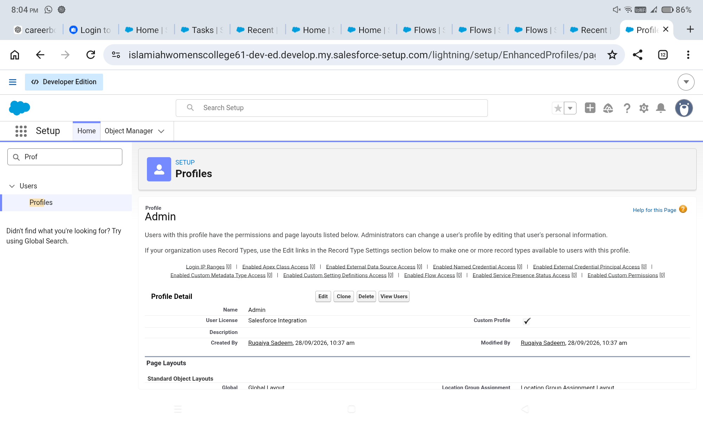

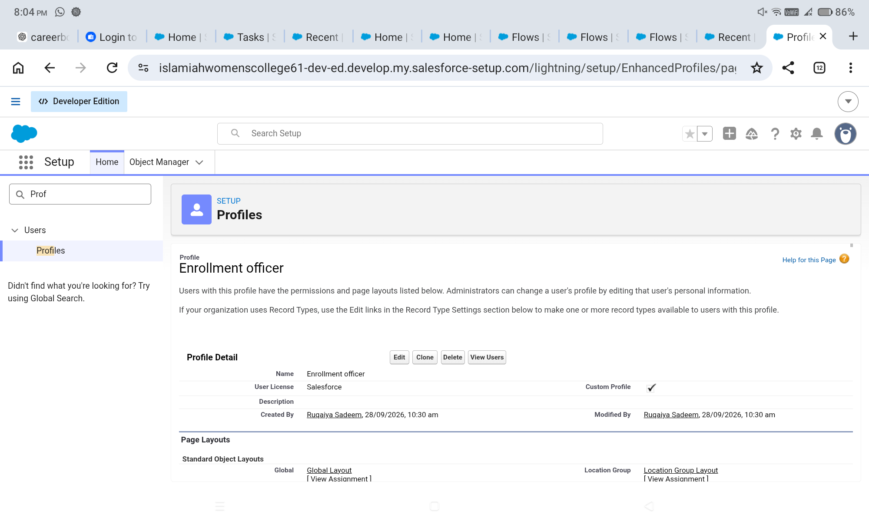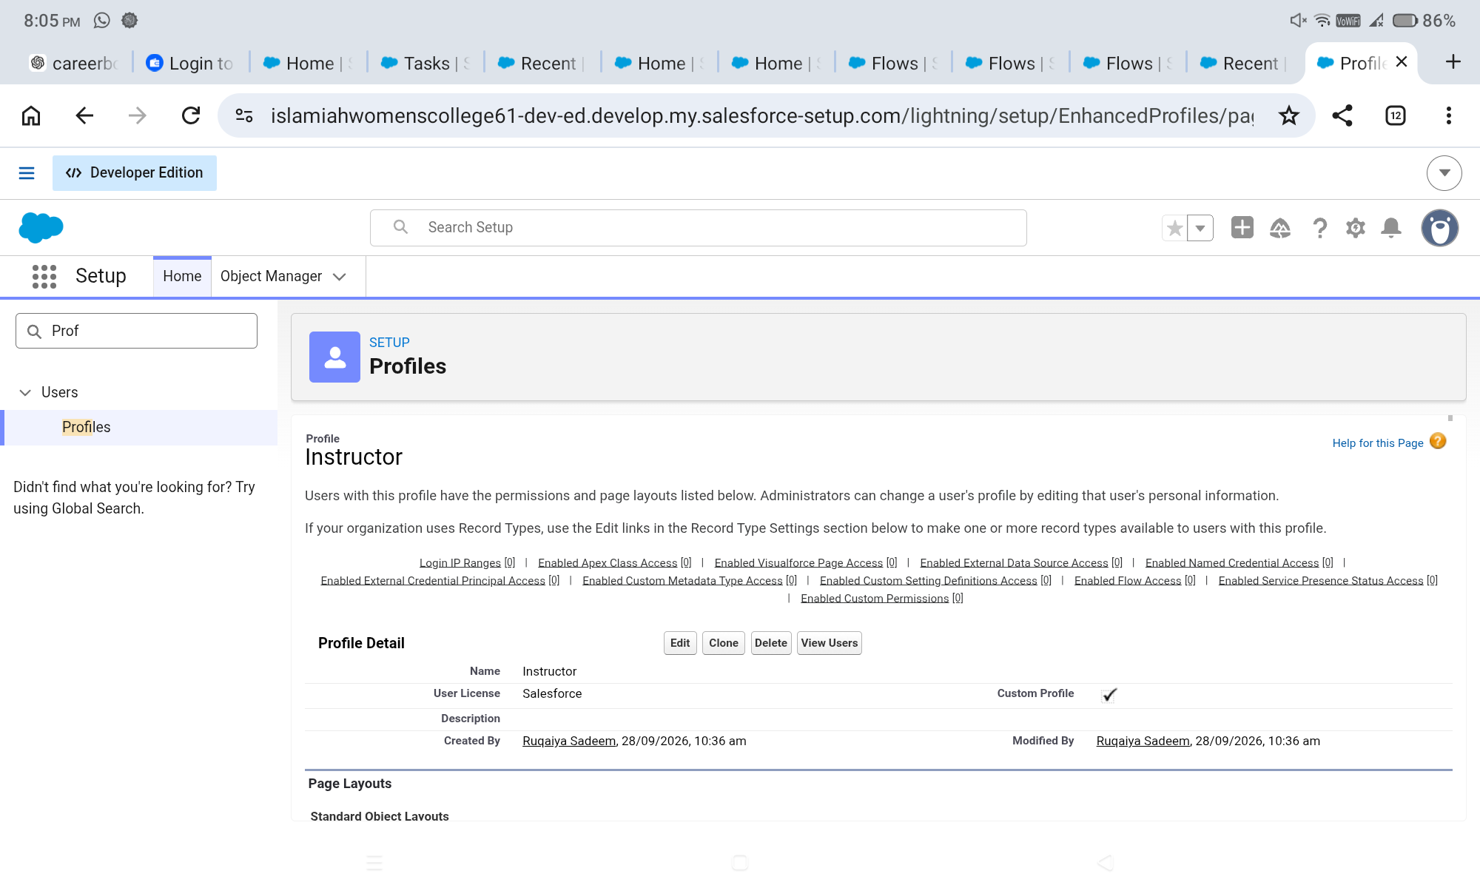

6.39 Permission Sets
Permission Sets provide additional permissions where required, such as project-object access or dashboard/report editing.

Development Process
- Create Custom Object Access permission set if required.
- Create Dashboard Editor permission set.
- Assign permission sets to appropriate users.
- Verify permissions.

Expected Result
The configuration should be saved successfully and should be available in the SECMS Salesforce application for the intended users and workflow.
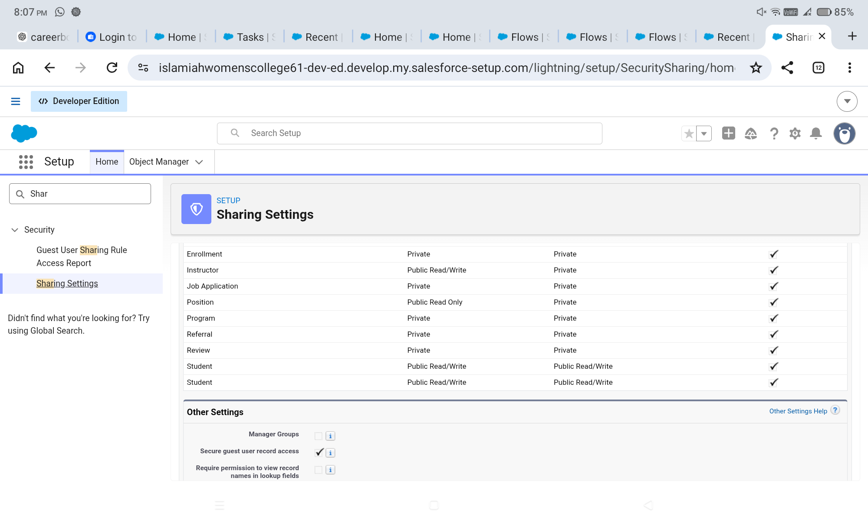

6.40 Sharing Settings and OWD
Organization-Wide Defaults and sharing settings control the baseline record visibility for project objects.

Development Process
- Open Sharing Settings.
- Configure Students and Courses according to the project access model.
- Keep Enrollment access restricted where required.
- Configure additional sharing or ownership logic for instructors if used.
- Save and verify access.

Expected Result
The configuration should be saved successfully and should be available in the SECMS Salesforce application for the intended users and workflow.

7. FUNCTIONAL & PERFORMANCE TESTING
Testing verifies that the configured Salesforce application behaves according to the project requirements. The testing section should contain the group's actual Salesforce evidence for record creation, validation, automation, approvals, reporting, dashboards, and access control.

7.1 Test Strategy
- Functional testing – verifies that each feature performs its intended operation.
- Validation testing – verifies that invalid or incomplete data is prevented where rules are configured.
- Automation testing – verifies that Flows and Approval Processes execute expected actions.
- Reporting testing – verifies that reports display the configured data and filters.
- Dashboard testing – verifies that components reflect the underlying reports.
- Security testing – verifies that users receive only the intended access.

7.2 Functional Test Cases
Test ID | Feature | Test Action | Expected Result | Status
TC-01 | Create Student | Enter valid student details | Student record is saved | Pass / update after execution
TC-02 | Create Course | Enter valid course details | Course record is saved | Pass / update after execution
TC-03 | Create Instructor | Enter valid instructor details | Instructor record is saved | Pass / update after execution
TC-04 | Create Enrollment | Select Student, Course and Instructor | Enrollment record is created | Pass / update after execution
TC-05 | Student Relationship | Open Enrollment and select Student | Student relationship is stored | Pass / update after execution
TC-06 | Course Relationship | Open Enrollment and select Course | Course relationship is stored | Pass / update after execution
TC-07 | Instructor Relationship | Open Enrollment and select Instructor | Instructor relationship is stored | Pass / update after execution
TC-08 | Record Type | Create New Enrollment | New Enrollment layout appears | Pass / update after execution
TC-09 | Record Type | Create Re-Enrollment | Re-Enrollment layout appears | Pass / update after execution
TC-10 | Related Lists | Open Student/Course/Instructor record | Related Enrollments are visible | Pass / update after execution

[ADD SCREENSHOT HERE – Representative successful record creation and relationship test]
Figure 7.1: Functional test evidence

7.3 Validation and Automation Tests
Test ID | Feature | Test Condition | Expected Result | Output
TC-11 | Student Email Validation | Enter disallowed email domain | Validation message is displayed | PASS
TC-12 | Fees Validation | Set Approved while Fees Paid is false | Approval is prevented | PASS
TC-13 | Enrollment Date Flow | Create enrollment | Enrollment date is populated automatically | PASS
TC-14 | Approval Flow | Set enrollment to Approved | Notification/update actions execute | PASS
TC-15 | Instructor Assignment | Use Technical/Language/Non-Technical course | Configured instructor is assigned | PASS
TC-16 | Follow-Up Task | Create Requested enrollment | Follow-up task is created | PASS

7.4 Approval, Reporting and Dashboard Tests
Test ID | Feature | Test Action | Expected Result
TC-17 | Approval Process | Submit Requested enrollment | Configured approver receives/processes request
TC-18 | Approval Result | Approve enrollment | Status changes to Approved
TC-19 | Rejection Result | Reject enrollment | Status changes to Rejected and notification is generated if configured
TC-20 | Students by Status | Run report | Records are grouped by Student Status
TC-21 | Enrollments by Course | Run report | Enrollments are grouped by Course
TC-22 | Pending Approvals | Run report | Requested enrollments are displayed
TC-23 | Revenue Report | Run report | Paid enrollments and fee summary are displayed
TC-24 | Dashboard | Open Student Management Dashboard | Configured charts, gauge and table display

7.5 Security Verification
Test ID | Role | Verification | Expected Access
SEC-01 | Admin | Open project objects | Full project administration access as configured
SEC-02 | Enrollment Officer | Create/update Enrollment | Create and update access as configured
SEC-03 | Instructor | View assigned enrollments | Read-only/restricted access as configured
SEC-04 | Unauthorized user | Attempt restricted operation | Access is denied or restricted

7.6 Testing Summary
The completed test suite should demonstrate that the core SECMS functions work together as an integrated Salesforce application. Final status values in the table should be updated by the group after inserting the actual test screenshots and confirming each execution in the Salesforce environment.
Note: Do not mark a test as Pass in the final submission until the corresponding feature has been executed and verified in the group's Salesforce environment.

8. ADVANTAGES AND LIMITATIONS

8.1 Advantages
- Centralized academic data management.
- Automated enrollment workflows.
- Validation of important data conditions.
- Structured approval processing.
- Automatic instructor assignment based on course category.
- Real-time reporting and dashboard visibility.
- Role-based access to relevant records and functions.
- Cloud-based access through Salesforce.

8.2 Limitations
- Dependence on the Salesforce platform.
- Initial configuration requires planning and administrative effort.
- Future integrations may require additional Salesforce configuration or external services.
- The current scope does not include the future-scope features unless separately implemented.
Area | Advantage / Limitation | Project Impact
Data | Centralized records | Improves consistency and accessibility
Automation | Flows and approvals reduce manual effort | Supports repeatable workflows
Reporting | Reports and dashboards provide visibility | Supports monitoring and decision-making
Platform | Salesforce dependency | Requires Salesforce environment and configuration
Implementation | Initial setup effort | Requires planning, testing and administration

9. CONCLUSION
The Student Enrollment & Course Management System demonstrates how Salesforce can be configured to support an academic enrollment lifecycle within a unified cloud platform. The project brings together Student, Course, Instructor, and Enrollment data and complements the data model with validation rules, approval processing, automated flows, reports, dashboards, and security controls.
The development work addresses the project requirements identified during ideation and requirement analysis. Centralized data management reduces fragmentation, automated workflows reduce repetitive manual activities, validation rules improve data quality, and reporting and dashboards improve visibility into academic operations.
The project also provided practical exposure to Salesforce configuration and the application of software-development concepts such as requirements analysis, data modelling, workflow automation, role-based access, testing, and documentation. The completed system provides a structured foundation for future enhancements such as student self-service, payment integration, analytics, and mobile access.

10. FUTURE SCOPE

10.1 Payment Gateway Integration
A future version can integrate a payment gateway so that fee collection and payment confirmation can be connected more directly to enrollment processing.

10.2 Student Self-Service Portal
A student-facing portal could allow students to register, view course information, submit enrollment requests, monitor approval status, and access relevant information.

10.3 Analytics-Driven Insights
Advanced analytics could be used to identify enrollment trends, course demand, revenue patterns, and operational bottlenecks.

10.4 Mobile Access Support
A mobile-friendly experience could improve access to selected enrollment and monitoring functions for students and staff.

10.5 Future Enhancement Roadmap
Phase | Enhancement | Expected Benefit
Phase 1 | Payment integration | More complete fee-management workflow
Phase 2 | Student self-service | Reduced manual interaction and improved accessibility
Phase 3 | Advanced analytics | Improved trend and performance analysis
Phase 4 | Mobile support | Greater accessibility for users

11. APPENDIX

Team Member Contribution
Member | Contribution Area
Ruqaiya Sadeem K F | Salesforce Developer Account Creation; Flow Automation; Reports; Conclusion and documentation.
Shaina Sadaf N Khan | Custom Objects; Fields; Relationships.
Moolakadai Musfera Konain | Tabs; Lightning App; Page Layouts and Record Types.
Vinothini S | Validation Rules; Approval Process.
Nivetha M | Dashboards; Security Setup.

Appendix B – Data Model Reference
Object | Key Fields / Purpose
Student | Student Name, Email, Phone, Date of Birth, Student Status, Address
Course | Course Name, Category, Duration, Course Fee, Description
Instructor | Instructor Name, Instructor Code, Expertise, Phone, Email
Enrollment | Student, Course, Instructor, Enrollment Date, Enrollment Status, Fees Paid, Total Amount, Comments

The Enrollment object acts as the central transaction object connecting the Student, Course, and Instructor records through lookup relationships.

Appendix C – Validation and Automation Reference
Configuration | Purpose
Student_Email_Domain_Validation | Checks that the student email meets the configured institutional-domain condition.
Fees_Must_Be_Paid_Before_Approval | Prevents approval when fees are not marked as paid.
SetEnrollmentDate | Automatically sets enrollment date on record creation.
Enrollment Approved Action | Sends approval-related notification/update actions and activates the student where configured.
AutoAssign_Instructor | Assigns an instructor based on course category.
Create_Followup_Task | Creates a follow-up task for Requested enrollments.
Approval_Enrollment_Request | Routes requested enrollments for approval or rejection.

Appendix D – Reports and Dashboard Reference
Report / Dashboard | Purpose
Students by Status | Displays student records grouped by status.
Enrollments by Course | Displays enrollment counts grouped by course.
Pending Enrollment Approvals | Displays enrollment requests in Requested status.
Revenue Report – Fees Paid | Summarizes paid enrollment fees by course.
Student Management Dashboard | Combines student status, enrollment, revenue, and pending-approval information visually.

